Herba Wander

E-Commerce Website

By Sunil Dangal

TAble of  
Contents

Introduction 1

Tech-Stack for this Project 1

For Frontend: 1

For Backend: 1

For Database: 2

For Hosting and Deployment: 2

Implementation 4

Frontend: 35

React 35

Tailwind CSS 39

Organising react project: 42

## Introduction

I am creating a E-commerce website to sell products for Everest Region Private Limited company. They have Best curated natural Shilajit, Moringa, Ashwagandha, Oils, Chyavanprash, Honey-related products and many more nutritional products. Now, I am creating a website, where customers can easily buy online with online payment using stripe.

## Tech-Stack for this Project

Now, I am using MacOS environment, and I am planning to use below tech-stack to build this website.

### For Frontend:

1. **React**:
   * For a highly responsive, interactive, and visually appealing user interface.
   * Use TypeScript for type safety and better scalability.
2. **CSS Framework**:
   * Tailwind CSS provides greater flexibility for modern designs.

### For Backend:

1. **Django**:
   * Use Django as the core backend framework for a robust, secure, and scalable backend.
   * Django's ORM simplifies database operations.
2. **Django Rest Framework (DRF)**:
   * For creating RESTful APIs to interact with the frontend.
   * API layer using Django Rest Framework (DRF) to expose product or user data for external consumption.
   * Provides excellent support for serialization and authentication.

### For Database:

1. **PostgreSQL**:
   * A reliable choice for managing complex queries, scalability, and relational data.

**Payment Integration:**

1. **Stripe API**:
   * Stripe provides extensive documentation for integration.
   * Offers support for various payment methods (credit/debit cards, wallets, etc.).

**Authentication:**

1. **Django-Allauth**:
   * Enhance authentication by integrating third-party login options (e.g., Google, Facebook) using Django Allauth.
2. **JWT (JSON Web Tokens)**:
   * For secure, stateless authentication between frontend and backend.

### For Hosting and Deployment:

1. **Frontend Deployment**:
   * Use **Vercel** for React deployment.
2. **Backend Deployment**:
   * Use **AWS** for Django.
3. **Static Files**:
   * Use **Amazon S3** or Django-storages for media and static file hosting.

**Additional Tools:**

1. **Redis + Celery**:
   * For task queuing, e.g., email notifications, order processing.
2. **WebSocket’s**:
   * Use Django Channels for real-time features like live chat.
3. **Search Functionality**:
   * **Elasticsearch** or **Algolia** for advanced product search and filtering.
4. **Testing**:
   * **Pytest** for backend, **Jest** for frontend.

**Steps for Development:**

1. **Plan**:
   * Define product categories, checkout flow, and admin panel requirements.
2. **Design**:
   * Use Figma or Adobe XD to draft the UI/UX.
3. **Develop**:
   * Implement APIs using Django and design the UI with React.
4. **Test**:
   * Test for usability, functionality, and responsiveness.
5. **Launch**:
   * Deploy and monitor user feedback.

## Implementation

So, let’s go to the project directory by cd. In my project directory, I have installed virtual environment by typing:

python -m venv virtue_inn

So, installing virtual environment will make sure, there are python installation, dependencies, python packages that will help to manage the project without any conflict. After creating virtual environment which is virtue_inn, we need to activate it by typing:

source virtue_inn/bin/activate

After activating, we need to install Django. So, we type:

pip install Django

After installing Django, we must create a Django project, so we type:

django-admin startproject herba_wanders

After creation of Django project, we are going to navigate to the project directory. And we can start the server by typing:

python manage.py runserver

After that, we will be seeing that the server has started, and it will give a local IP to see the development server. And we can open the IP and It will show “The install worked successfully! Congratulations!”

After this, to create the Django app, we need to stop the running server so, we can do >> Ctrl start << in console and start by typing:

python manage.py startapp ecommerce

So, our current file structure looks like this:

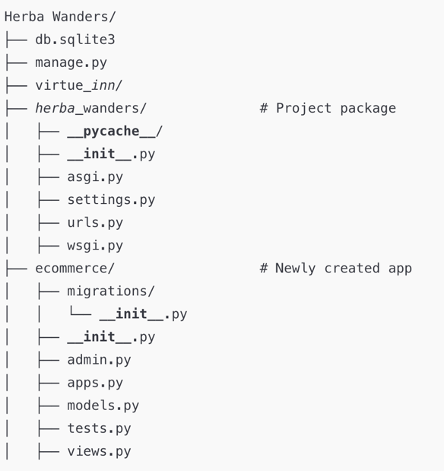

So, In Django, MVT structure, herba_wanders which is the project package which contains project configurations files, and the newly created ecommerce contains the application. After creating this application, we need to register the application name which is “ecommerce” in the settings.py file.

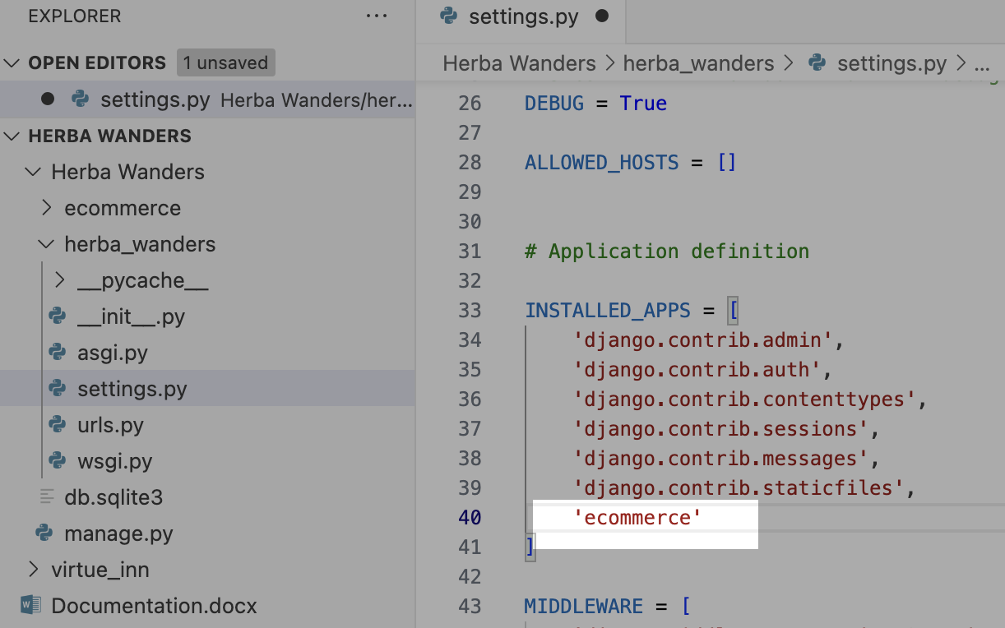

Now, we are going to create a view that gives HTTP response and template for our website pages. We are also going to map the URL to the view. So, lets navigate to the ecommerce directory and open views.py and create a function for all the page view.

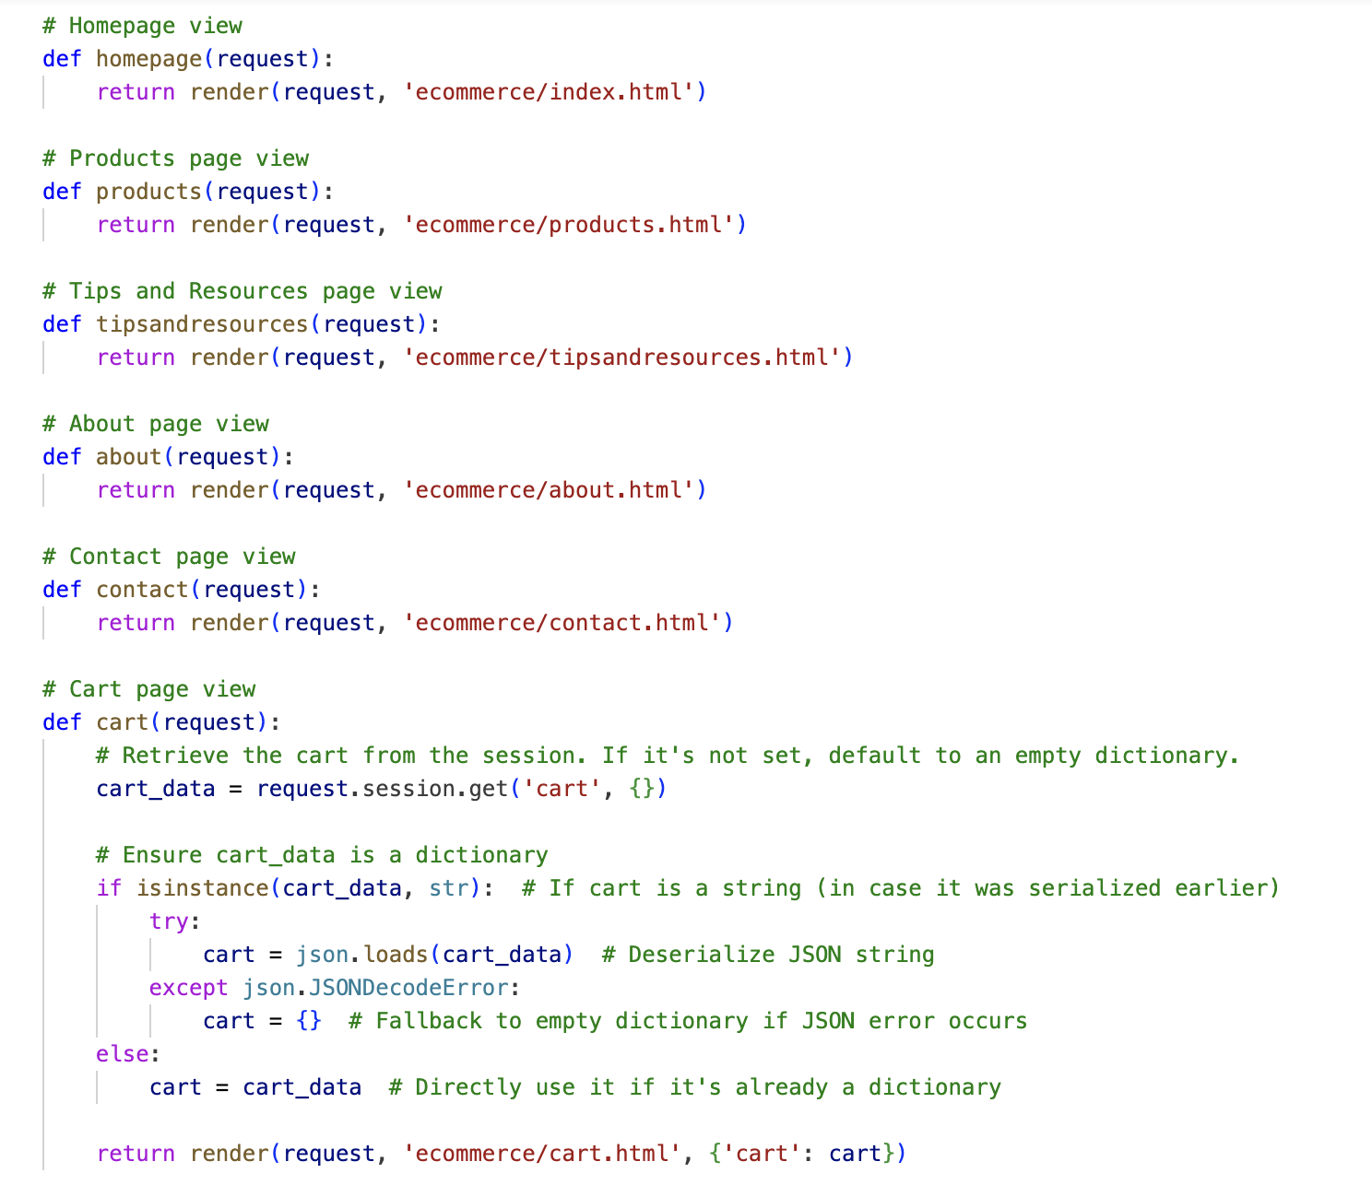

Now, we are going to map the URL to all the respective functions. For that, we need to create new file name “urls.py” inside ecommerce application. And inside that we do this:

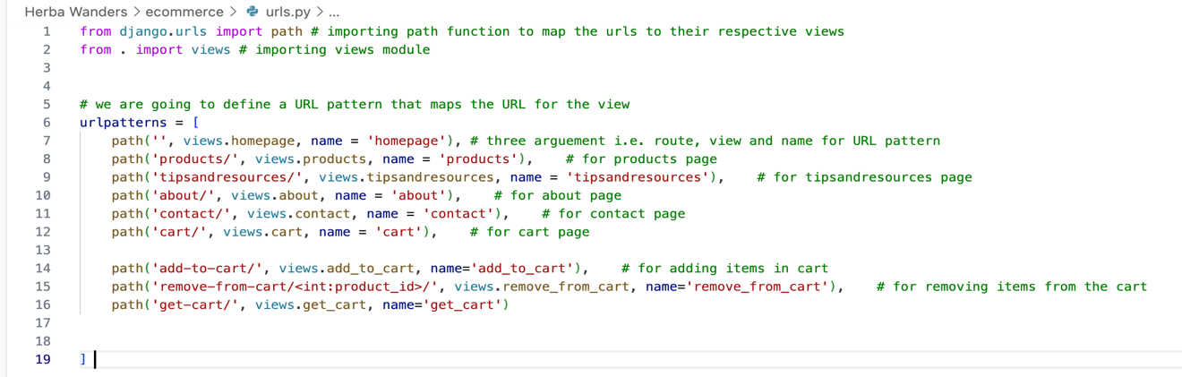

After defining URL, we also need to ensure that the above URLs is included in Main URLs file. We need to add the URL pattern that we created inside the Main URL file.

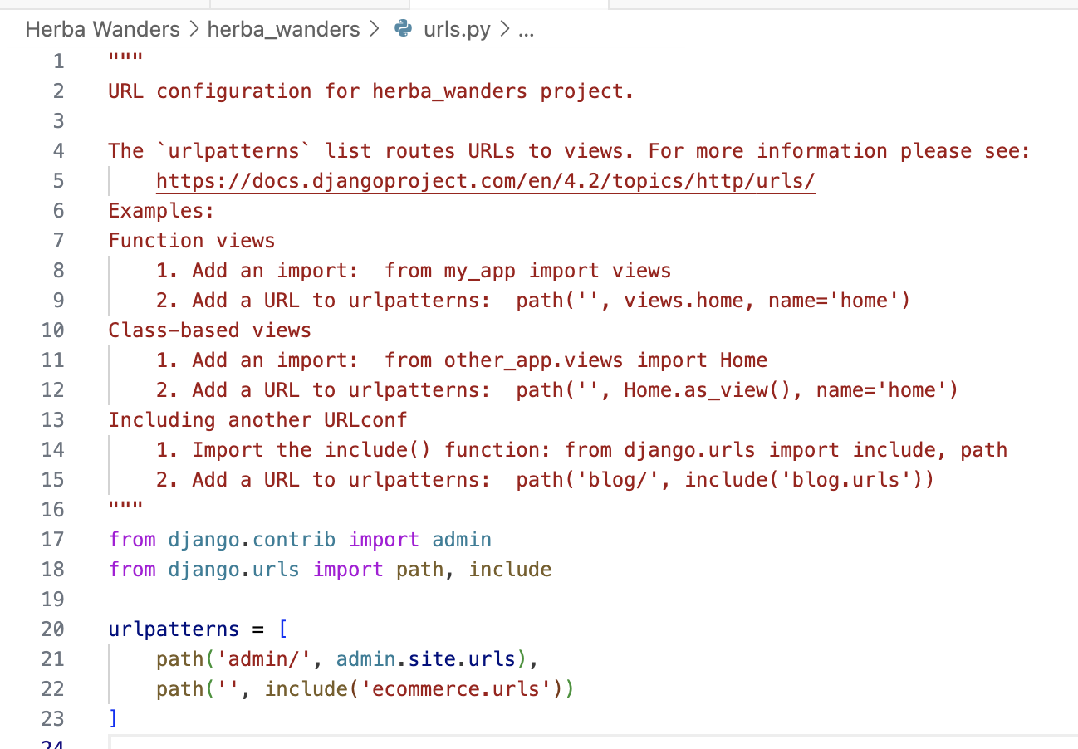

We need to make separate .html files for every page that we want to load inside templates folder. This is what the file structure looks like after I have added the pages, static files, images, etc.

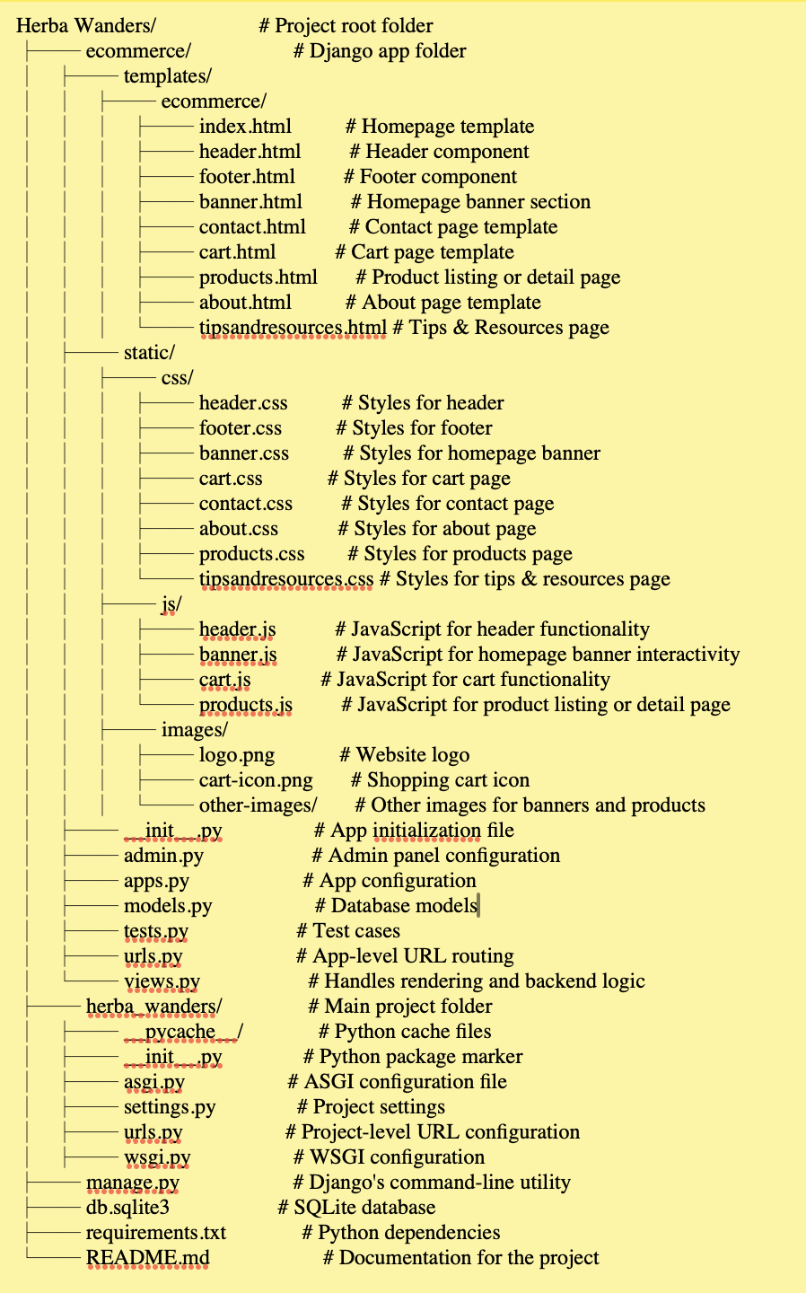

Now, after running our server by doing python manage.py runserver and going to this link = [http://127.0.0.1:8000/], we can see that the page is loading. So that is the way, we have mapped and resourced our URL. Now, we can update the code to load the HTML page. For that, we need to create a directory inside by doing:

mkdir templates

inside the templates folder, we create another folder name header by:

mkdir ecommerce

and inside header folder, we create index.html file by doing

touch index.html

So, we can create more html files, .css file, js file for other pages like in above pic, we need to update settings.py to locate our template folder to load that for us. Inside the settings.py file, we need to update the DIRS. We write [BASE_DIR + “ecommerce/templates”] to show the location of templates directory.

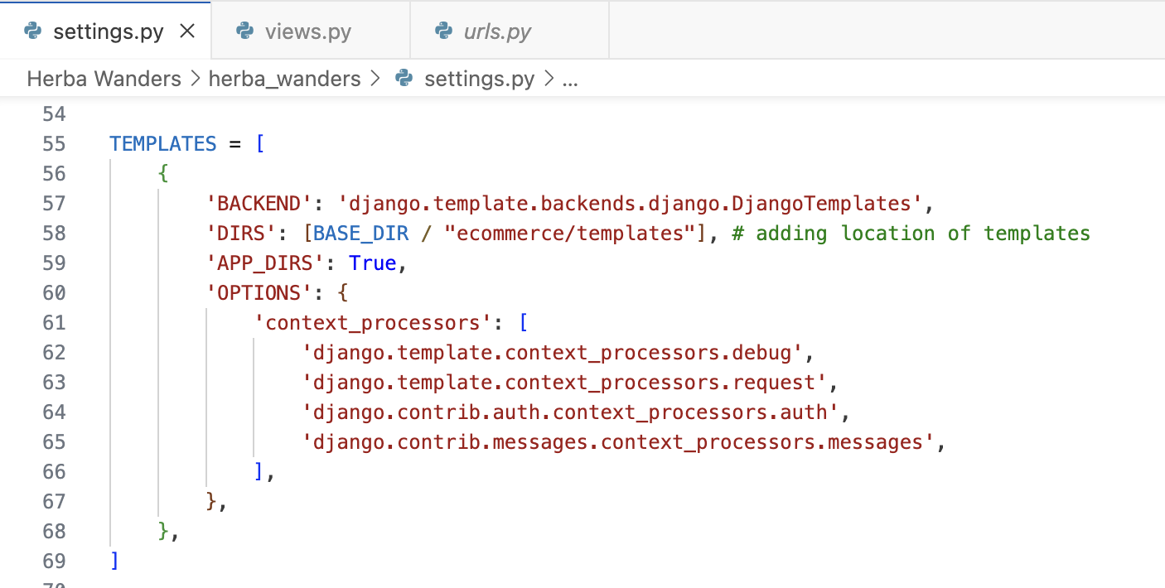

Now, we need to update all the function in views.py to return the HTML page. To return HTML page, we replace with render. The function takes the request and returns HTTP response with renders template.

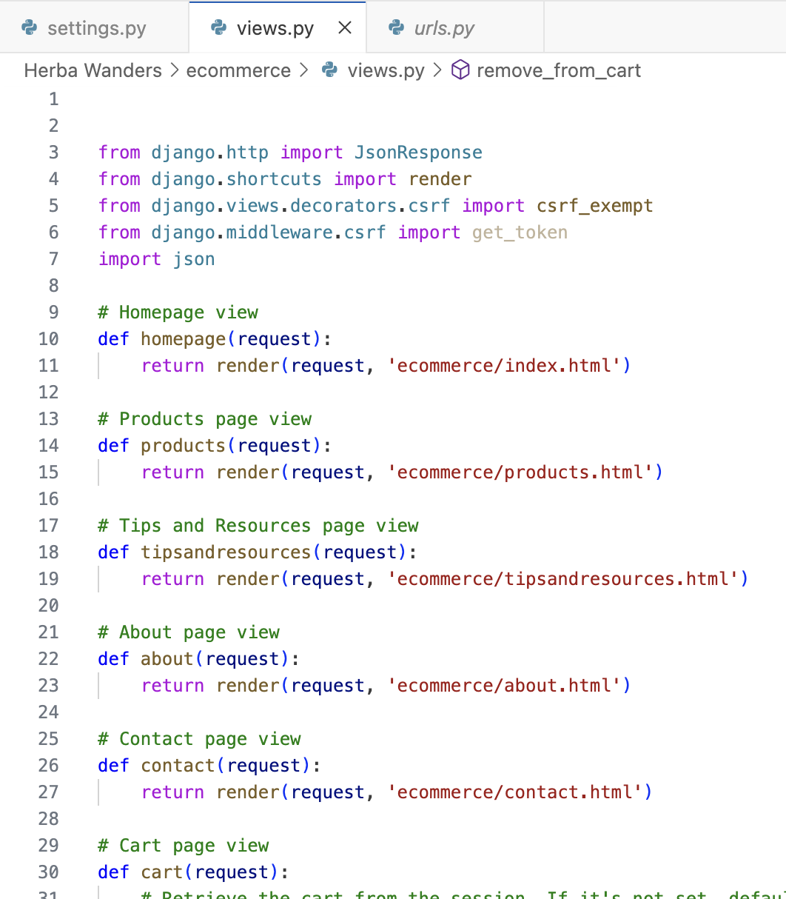

Now, if we go to the main project home directory and run the server, we can see the rendered e-commerce page. Likewise, we are going to add all the pages required for the e-commerce website and make the frontend look professional. Now this is a basic overview of how I added and loaded the webpage. I am going to do same for all the rest of the pages and add more pages if required. Also, to add a functionality like for example to make the cart work with adding, removing, paying, etc., we need to add these functionalities inside the views.py.

Now, for the ecommerce website, we need to create lots of models like for users who signs up, we need user model, Product model for adding products, category model for easy navigation for products and categorization of products, cart model, cartItem model, order model, orderItem model, Payment model, Shipping model, Review model, Wishlist model, coupon model and etc., if we are going to add coupons or other features.

Now, for now, I am going to create models for product. This product model will have around 9 attributes, name, description, price, stock, image, created_at, updated_at, is_active, slug. Basically, models are useful for admin to add or delete or modify objects that we see inside website. It is easy to navigate through Django admin panel and making models will make it easy. So, we are going to go to models.py and make product model there.

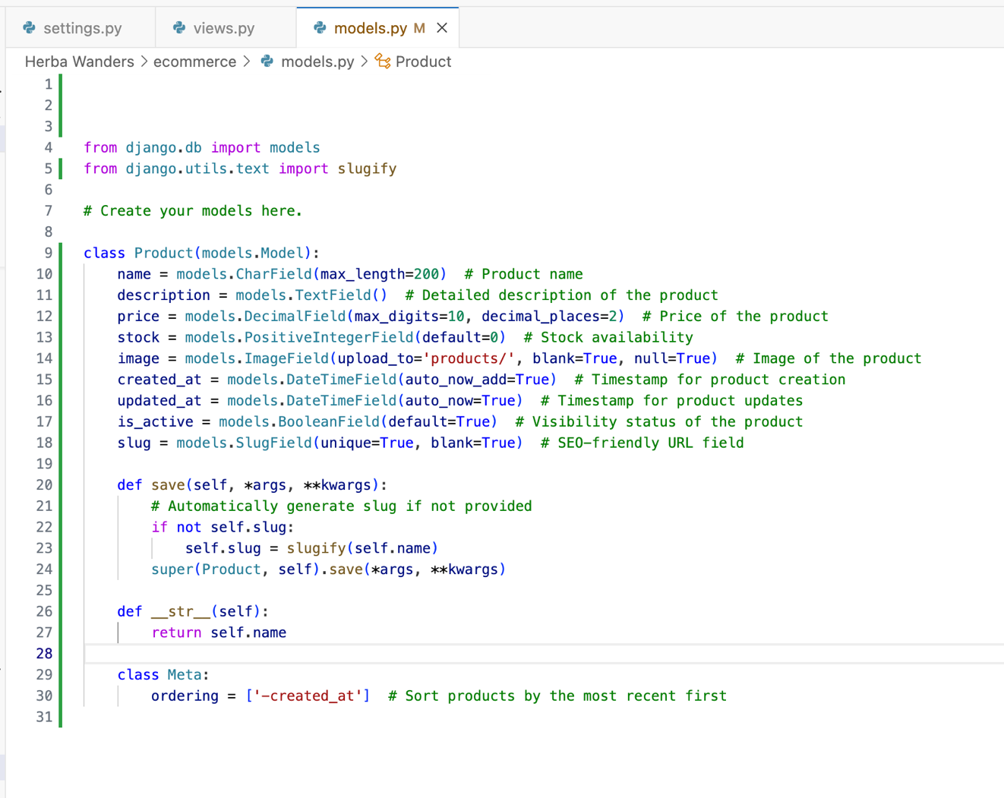

So, after creating model like above, we need to run two commands in command line.

1. python manage.py makemigrations
2. python manage.py migrate

So, while doing step 1(python manage.py makemigrations), we might encounter issue with pillow installation so if it is not installed, we must install it because Pillow library is used in handling image-related tasks, such as processing and saving images for the ImageField.

1. We are doing step 1 (python manage.py makemigrations), because this will let Django, how the database will be changed and managed.
2. After that, we do step 2 (python manage.py migrate) because it will let the Django database know that the database will be changed for the attributes, we created for product models.

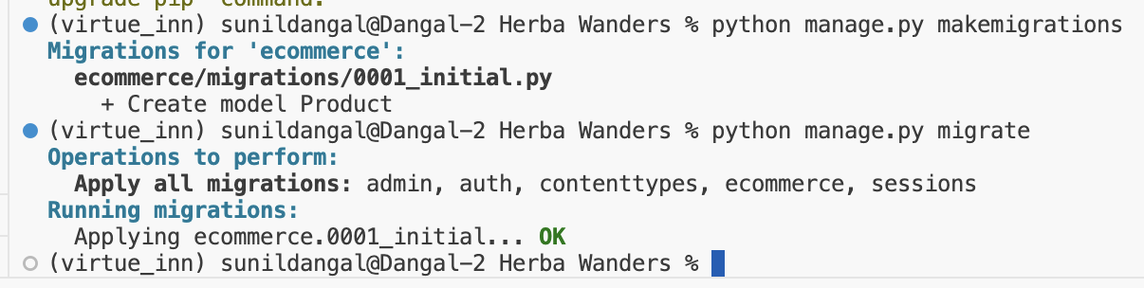

Running above lines, will updates the database structure so that we can add data of product and rest of the other models correctly.

Now, we are going to setup Django’s admin panel. Basically, admin page is for managing models. Admin page will also have CRUD operations for the models. Now to access the django’s admin page, we need to create superuser first so we do:

python manage.py createsuperuser

Now, we can just fill the details of username, email, and password. After that, we run our server and if we go to the link = [http://127.0.0.1:8000/admin/], then we can see the Django’s admin interface. We then type our login details, and we can see, we can manage models from the UI of Django. Now, if you noticed, we didn’t saw the product model that we created before. So to add product model, we have to go to admin.py and register our models there and then only we can access and do CRUD operations there using Django’s admin

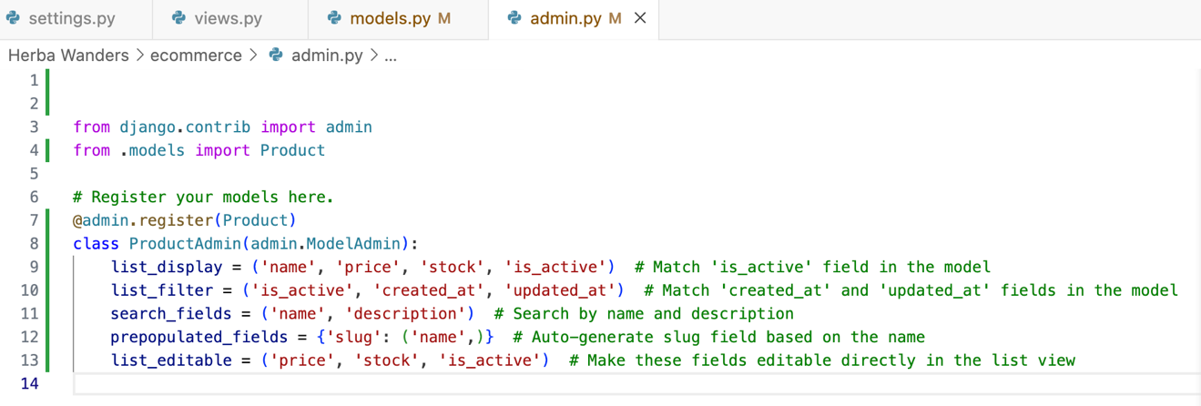

So, this is the code to register model and its attributes inside admin.py

Here, after making product models and registering inside admin.py. We can then run server and we can see products is added inside Django administration.

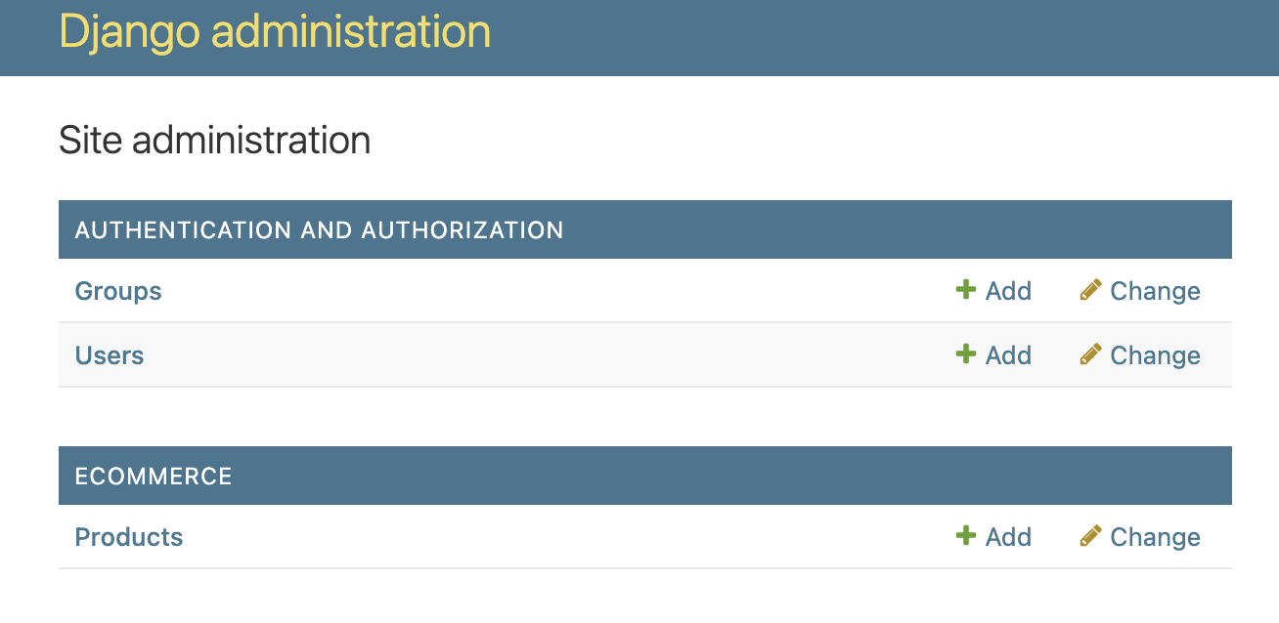

Now, we can add products and it details directly from the Django administration. Now to have product displayed inside our webpage, when we add new products from Django administration, we need to also update our products.html page. Check below I have updated the code inside products.html.

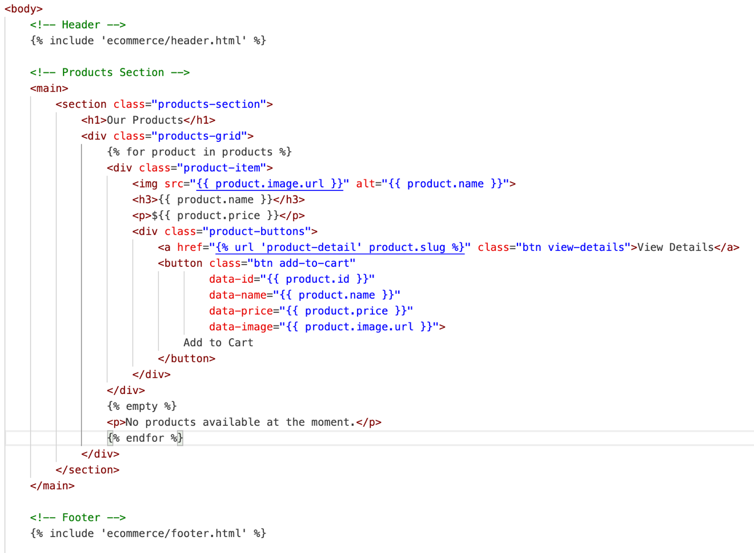

Now, after this, we need to update our views.py file for our product function.

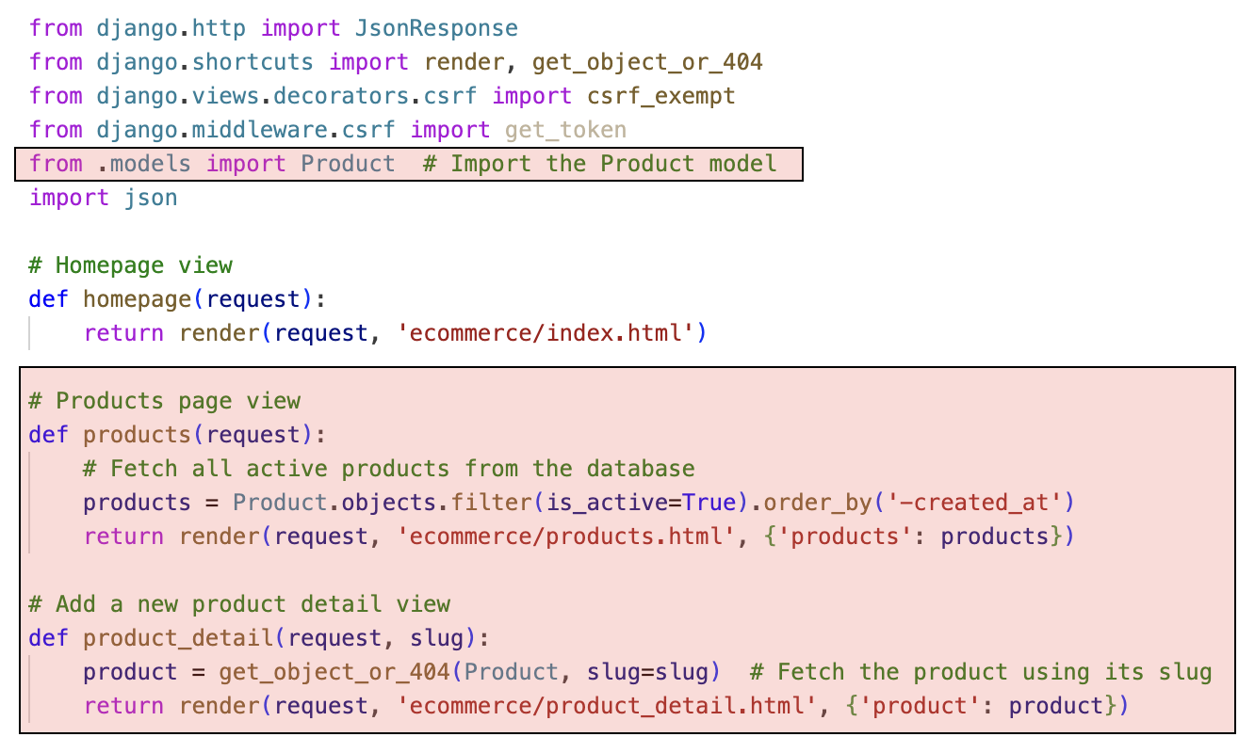

Now, we have applied changes in views.py for our product function. We add a new function product_detail .

Also, in urls.py file, we have to apply changes for the route, so I did this:

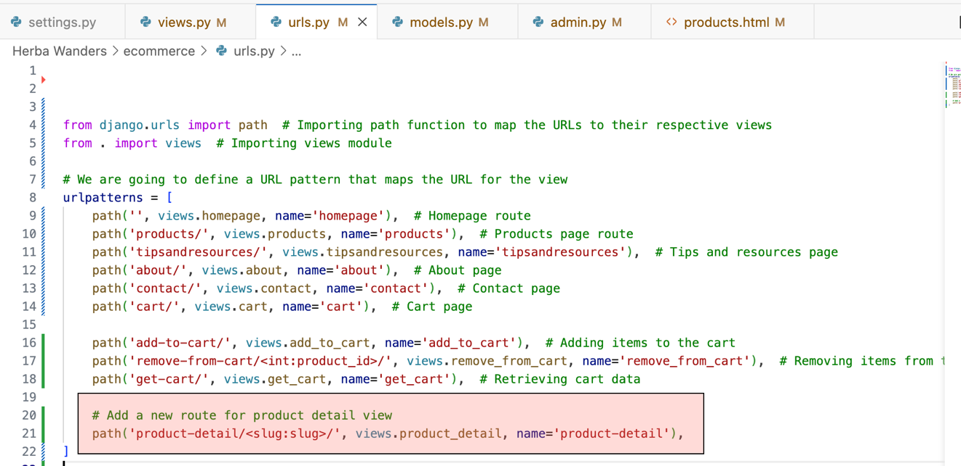

Likewise, we do same for all the models that we plan to add inside Django’s administration and do CRUD (Create, Read, Update and Delete) operations.

Now, when we add the new products, we can see that it is shown in webpage. Issue is the image is not loaded for the product. So, to have the images loaded and to handle static and media files in Django: we need to update code in settings.py file.

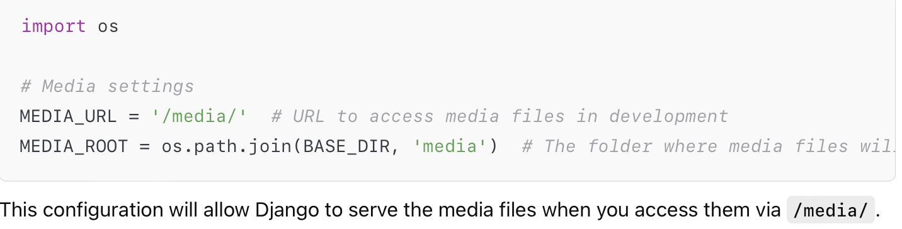

After adding above, we need to update code in our urls.py which is in herba_wanders folder. This will ensure that media files can be used easily during development.

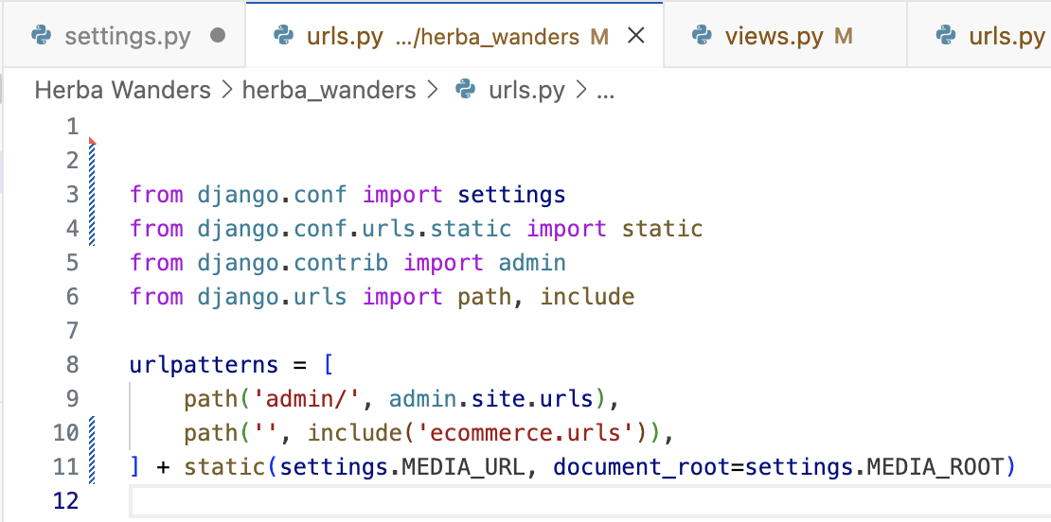

Now, we also need to update models.py for image field to handle image properly where in our situation, it is already updated as in above pic. Likewise, we also need to ensure, in products.html, the img tag is set up to load images correctly from the media folder.

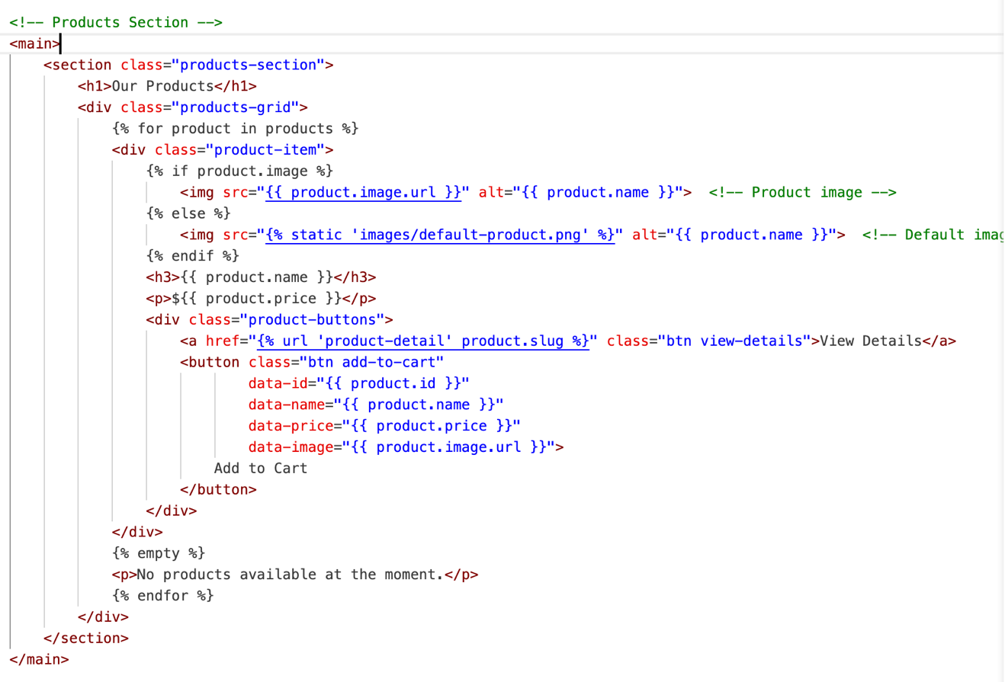

So, this is updated products.html again to ensure the image location is right.

The process of how I added product models for adding product details from Django administration, we can do same for all the things we want to add from Django admin. I am going to add blog inside Tips and Resources page later and I will also add team details later in About us page using the same process as how I added for products page.

For now, I am going to look at Django user object model. This system is located inside Django.contrib.auth package. This user model system is a pre-built feature and part of Django’s system which provides services for user authentication, services for user accounts in web applications like this e-commerce website. This is a full-fledged authentication system designed to manage user accounts, groups, permissions, and even cookie-based user sessions. We will be using these systems to create user accounts, log in, signup and authentication.

Now let’s create a login system for user to login. Let’s stop the server and do:

python manage.py startapp users

It will create a user’s folder inside our main folder containing all the same element as we made for Herba wanders folder before. Inside here, we are going go to create user functionalities. Now, we need to add user’s app inside Herba Wanders settings.py to access information when logged in later. So, let’s go to settings.py in herba_wanders configuration and add users inside Installed Apps section. We could create any functionalities of the user here later if we wanted to.

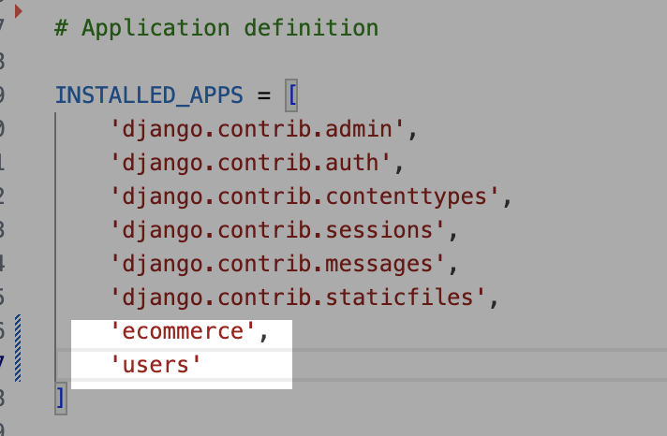

We are using Django’s superuser as a user’s login.

Now, we next thing we need to do is create urls.py file inside our newly create users app. We are going to create a server and user app where we will have user functionalities there. Now, to create a user app we are going to do same as before.

Now, we also need to update urls.py in herba_wanders which is the urls.py of the overall project. 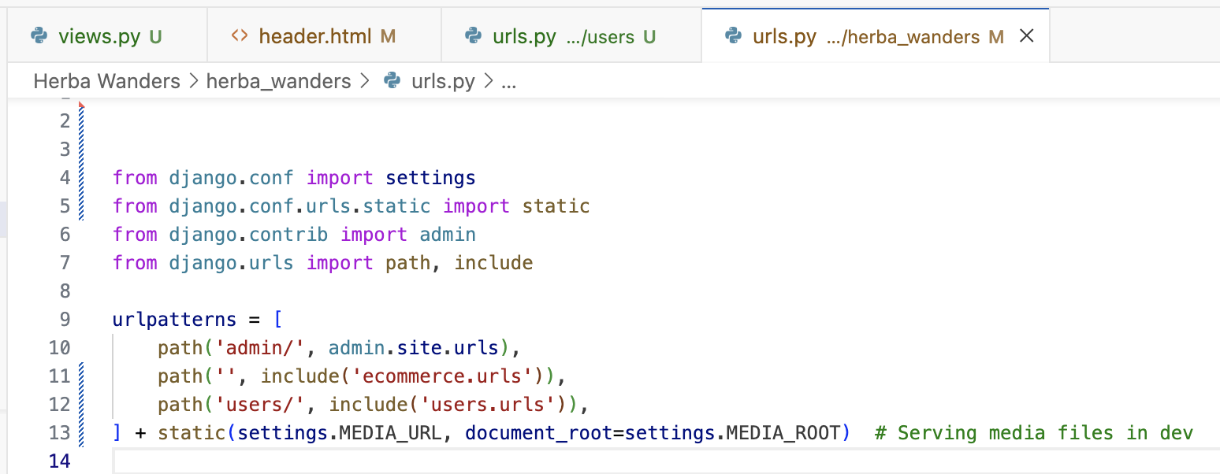

Now, that we have connected users.url in global urls.py file. Next thing we need to do is create login system. So, inside our newly created urls.py file, inside users app. 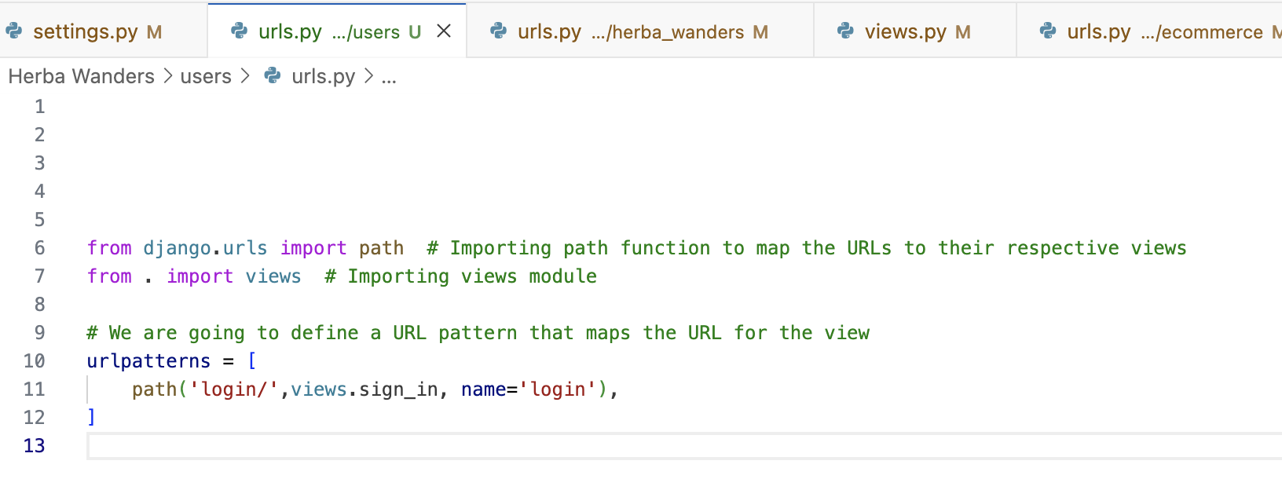

So, Above, we stated that the path will be login, connecting to the views of sign in, and naming login for easy access.

Now, we will create a forms.py file inside the user’s directory which we just created before.

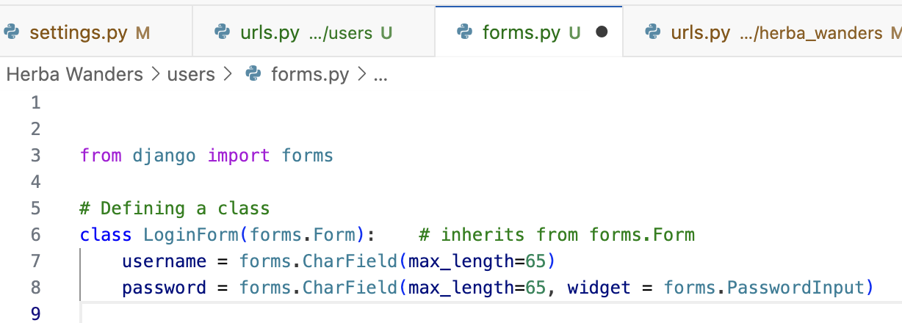

Now, we need to go to the views.py file inside users directory to connect the forms.py file. Inside views, we do this:

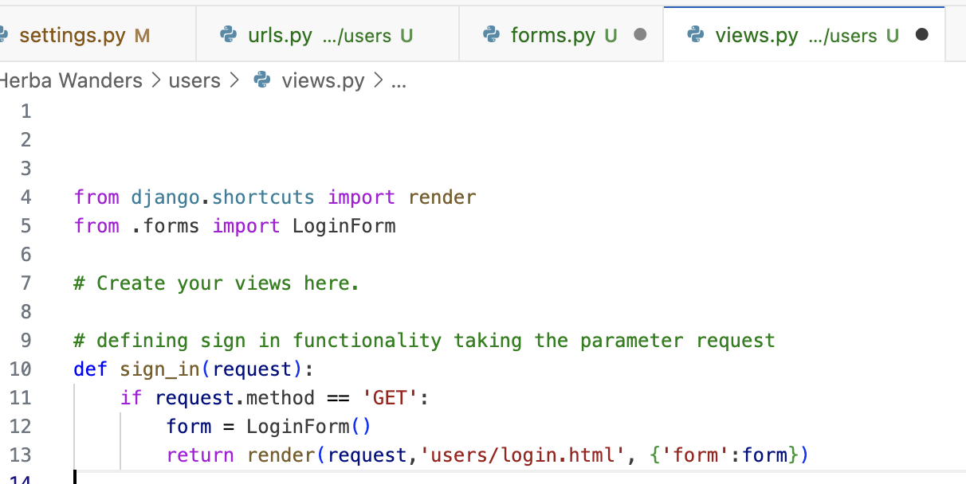

Now, next thing we need to do is create a user’s folder inside template folder and inside user’s folder, we need to make login.html file and inside login.html we put html codes. Now, when we access the link = [http://127.0.0.1:8000/login/], we can see login section.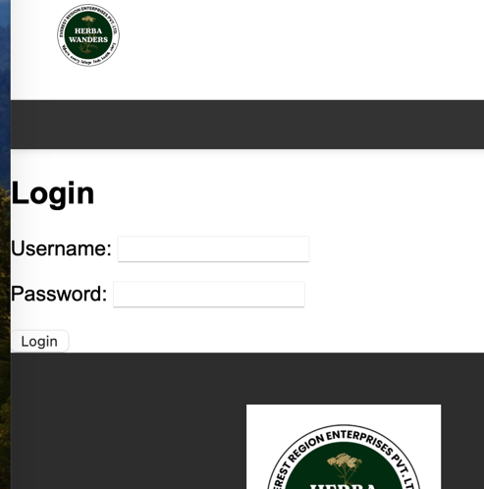

In the login.html file, to have login functionality using Django’s default user, we have POST method which means the form will send the data to the server using HTTP attribute and we have put novalidate which basically tell browser not to validate before submitting. It also allows Django’s form validation later.

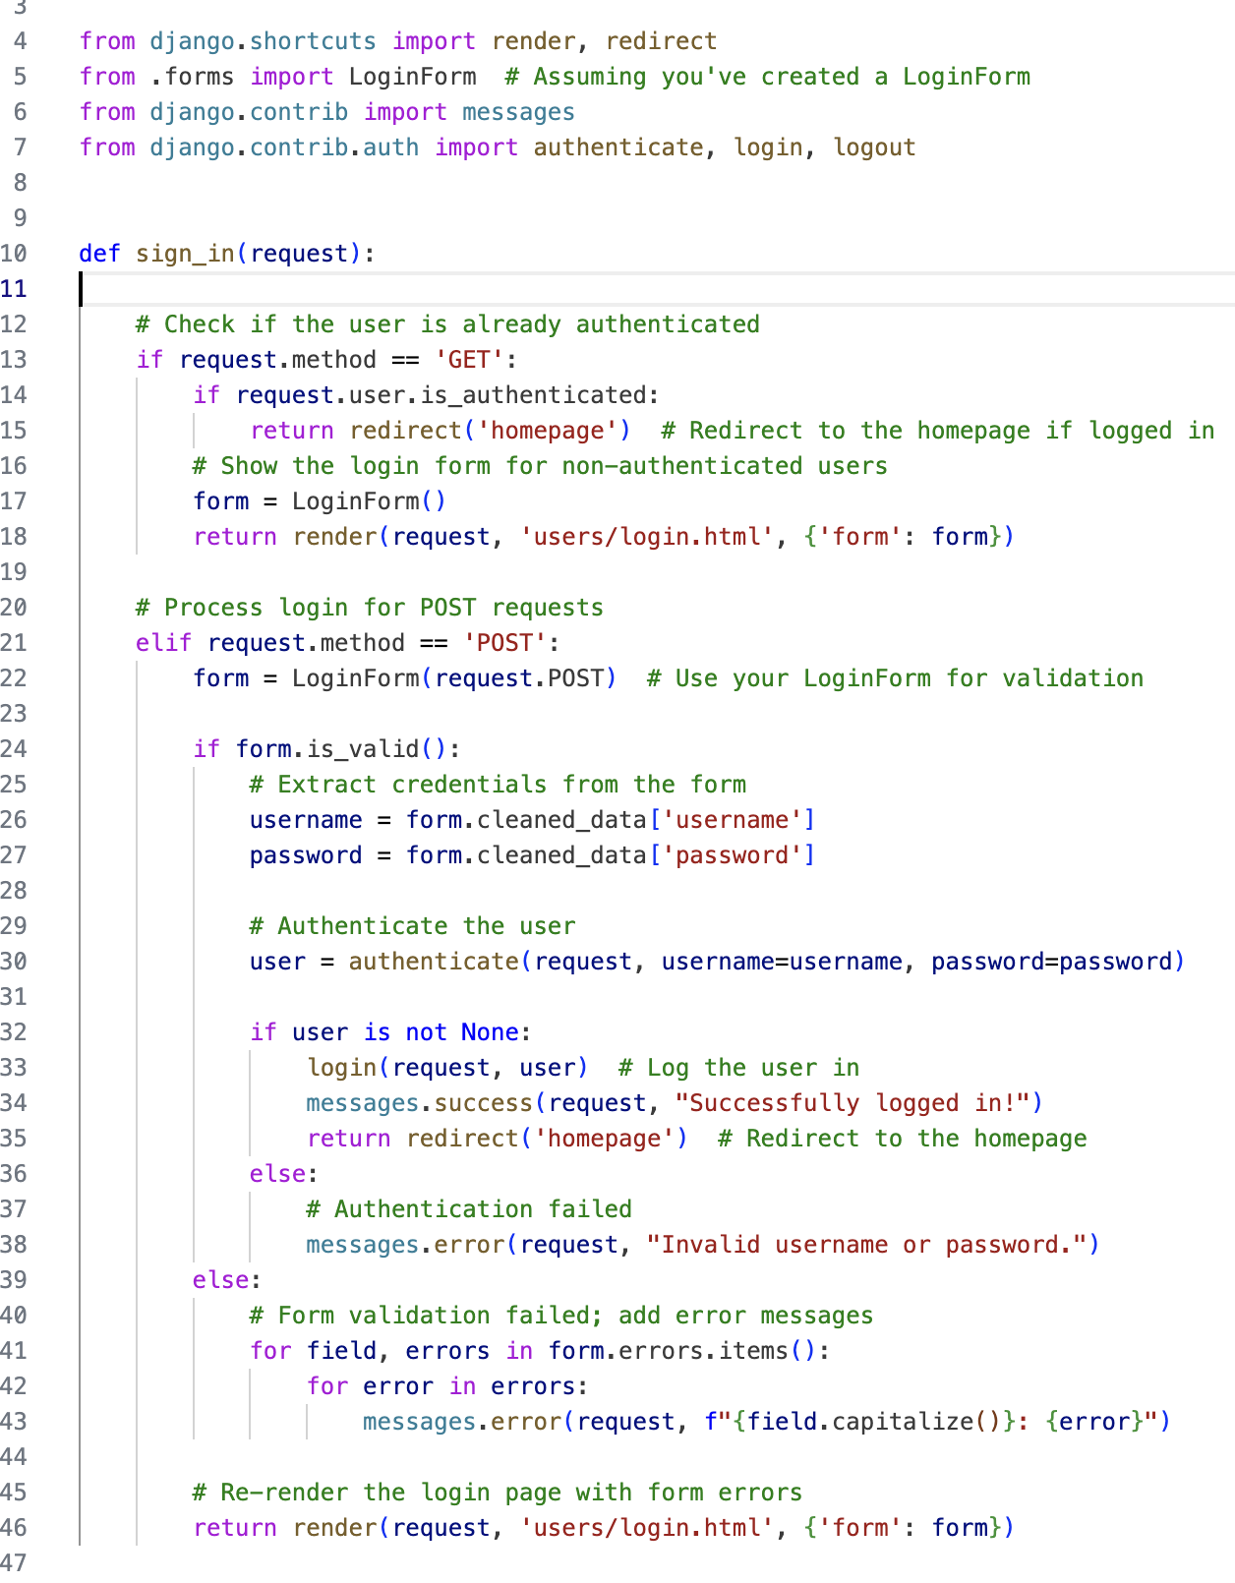

We also need to update this in our header.html

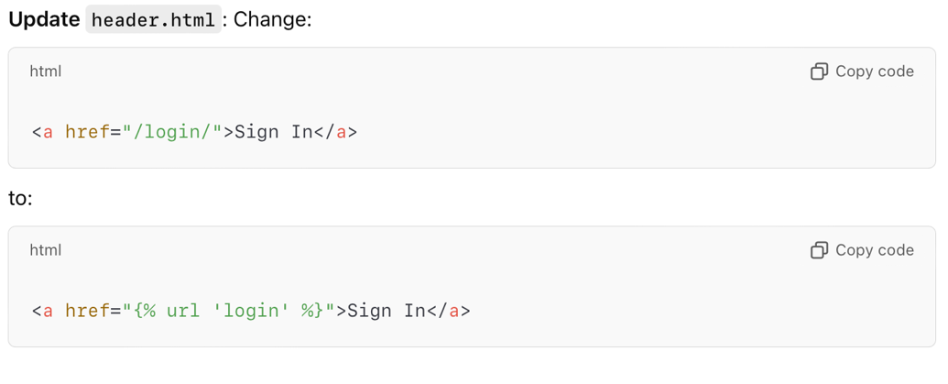

Now, we are going to have logout functionality using Django’s default user. Now, just like before, we are going to add a new path for logout inside urls.py in users folder.

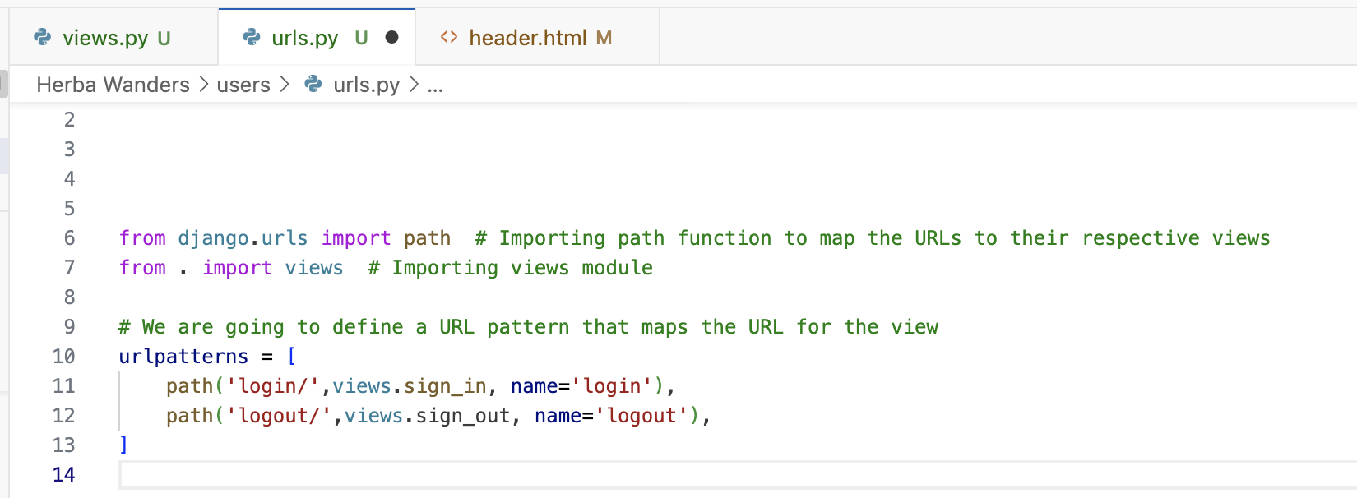

View will be connected to the sign_out functionality. Now, just like before, inside views.py file, we need to create function for logout functionality.

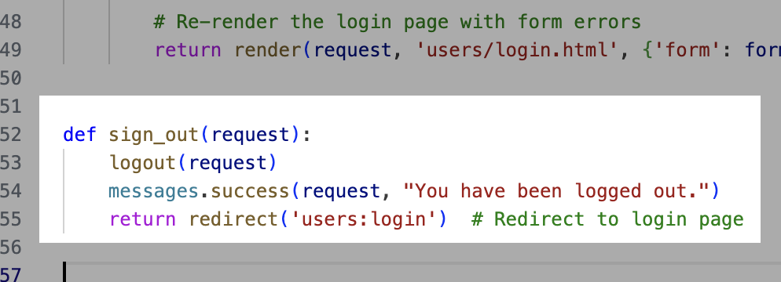

So the sign_out function will take request as a parameter. We have used logout functionality provided by Django. And then it will return redirect to login page.

We have also updated code inside header.html for login and logout code. We have added dropdown menu for showing account info where we can login and logut from there and check user information later.

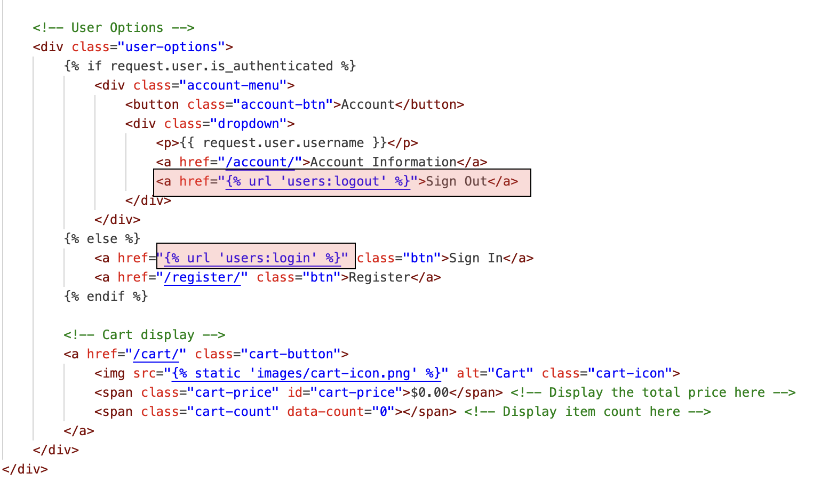

Now, we can sign-in, and sign-out and it takes back to login page.



Now next thing, we are going to do is make the register system work for users. We are going to use Django default process for registering users. We are going to create a form for user input first, define a function inside views.py to handle forms submissions and finally create url path to map this view. Django’s had built in form which is UserCreationForm which let us create form for registration.

Firstly, we are going to create a path to register in urls.py in users folder. Linking views to sign_up functionality. We are defining as register.

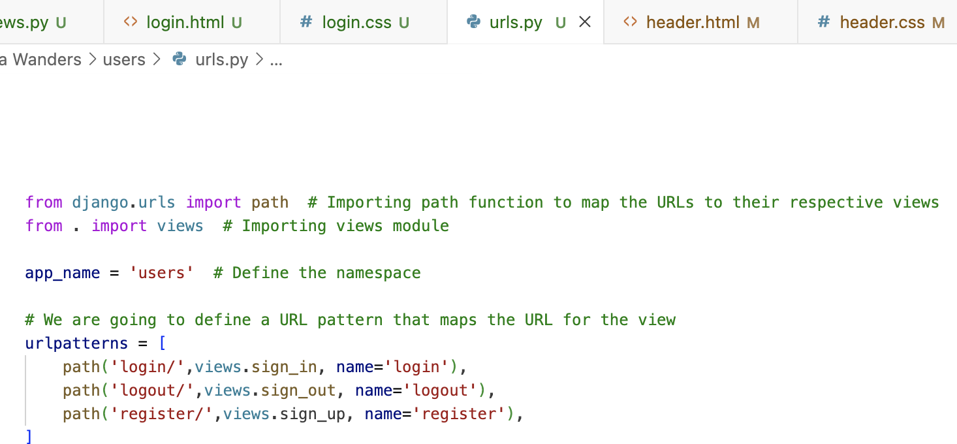

Now, after creating url path, we go to forms.py file and create a form for user registration inside. I am going to create a RegisterForm class inheriting from Django’s built in UserCreationForm.

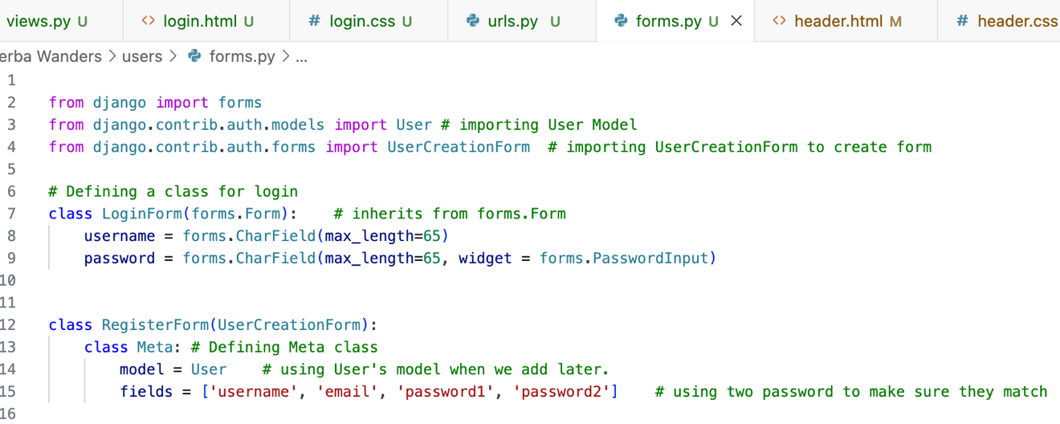

Now, after this, we need to go to the views.py in users folder to create the registration view. Inside views.py, we define sign_up function. We need to make sure, we have imported RegisterForm like this = [from .forms import LoginForm, RegisterForm

]

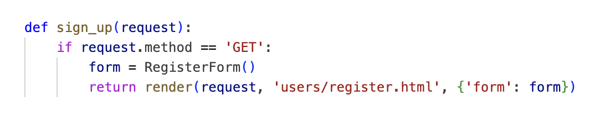

We also create register.html file inside users directory and add registration code. After that, we also need to update the source location for register inside header.html.

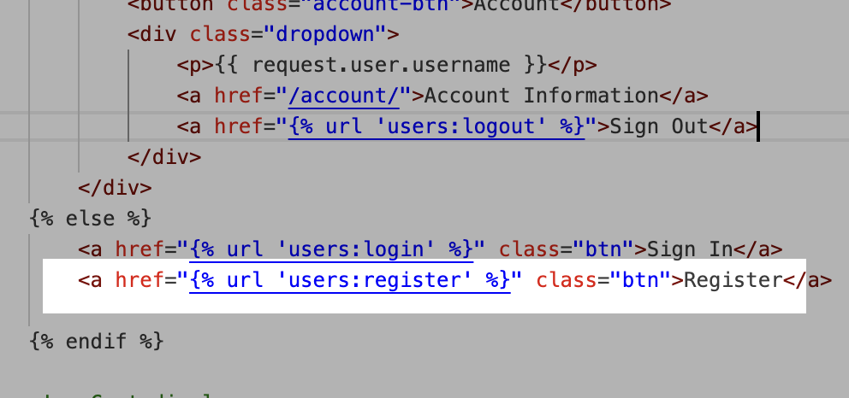

And after that, we just run our server and we can see the registration page appear when we click register. We can then create styles and arrange according to our desires.

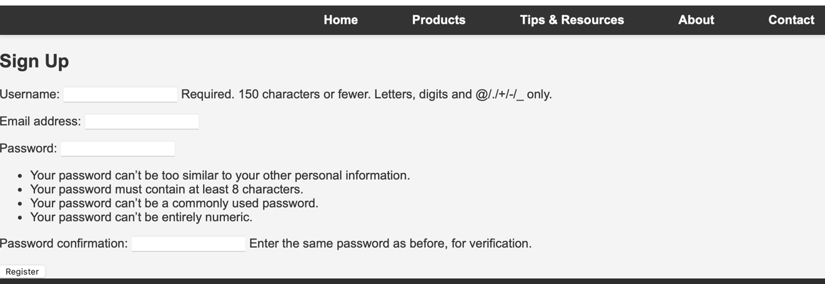

Now, next thing, we need to do is add the registration functionality. So that we can register account. So, to have the functionality, let navigate to views.py inside user’s folder and update the code for registration functionality and handle the POST method.

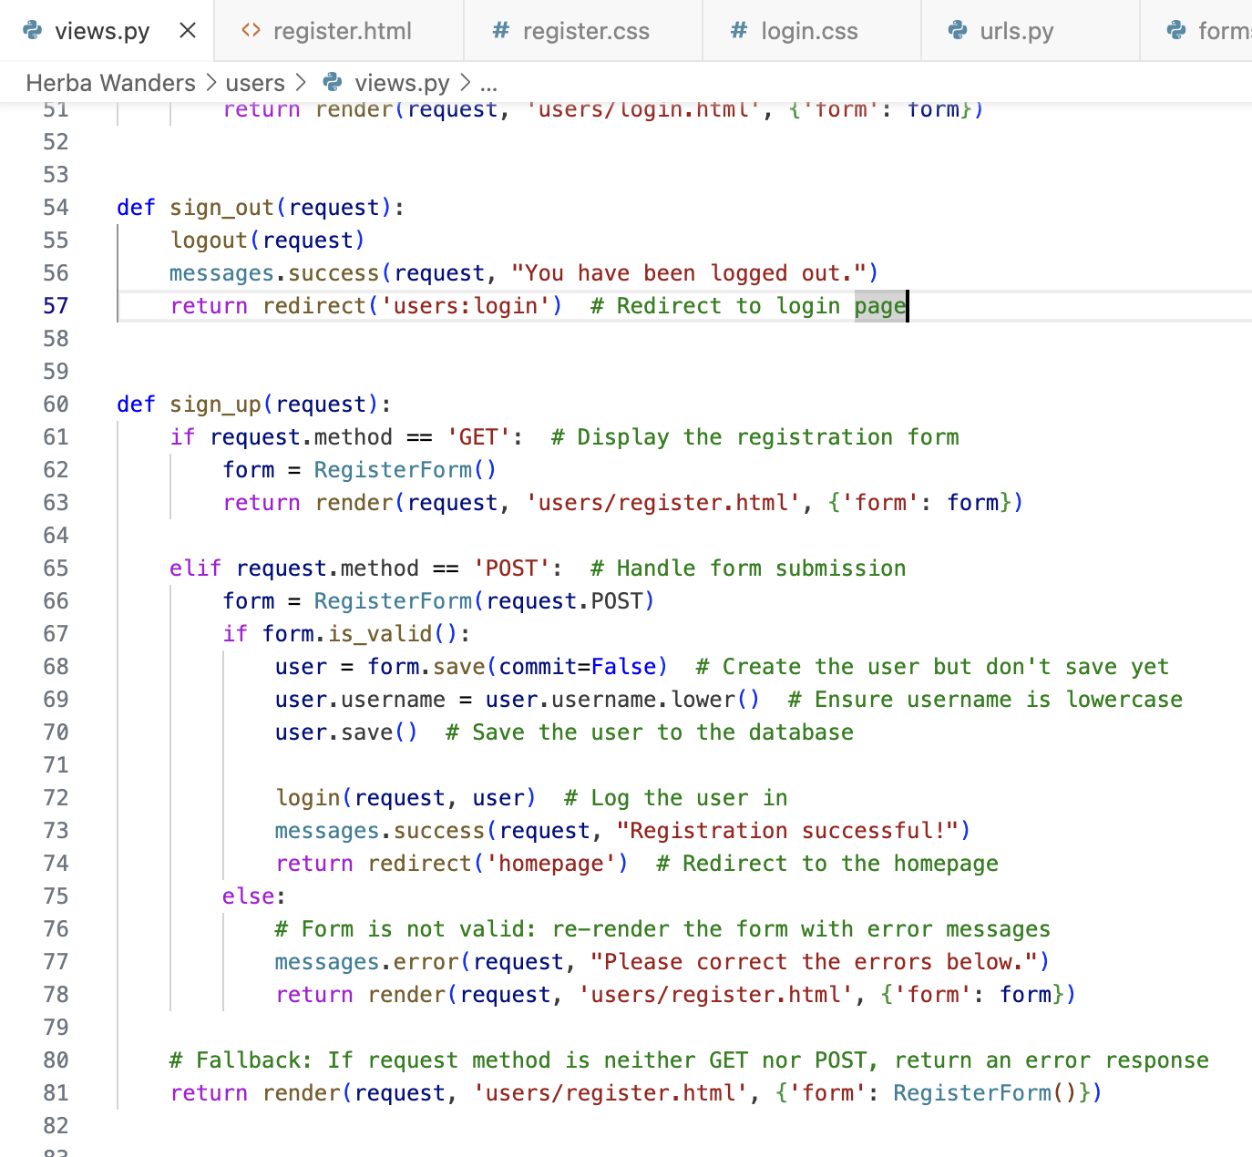

Now, after writing if and elif statement for handling registration in views.py file, we can register new user and they can login. So, we have finished the signing, sign-out, and signup functionality for this e-commerce website.

Now, we have a pending tasks that we didn’t finish before about creating models. We are going to work on creating model for the rest so that we can directly update models from Django’s administration panel.

Let’s create models for Tips & resources page. So, for Tips & resources page, we are going to write code inside models.py

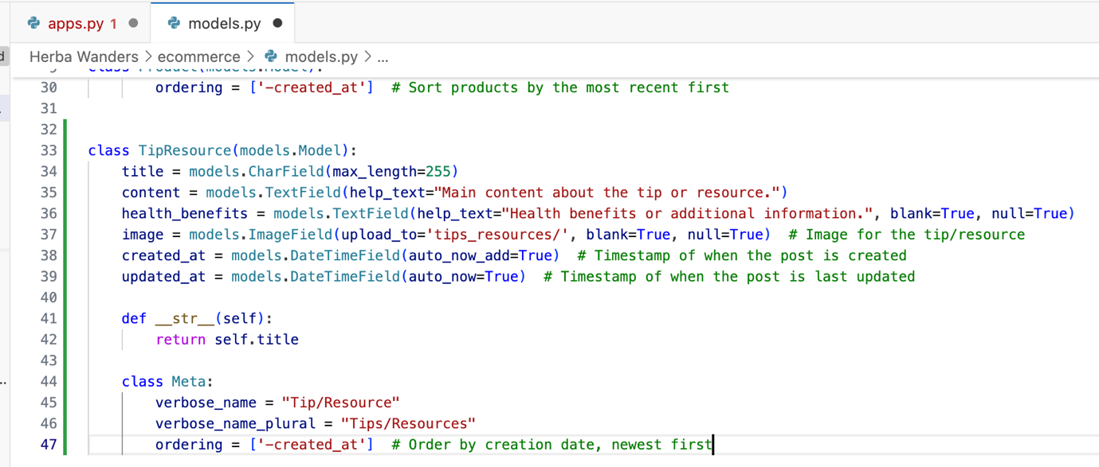

Now, just like before, lets run the magic two commands:

1. python manage.py makemigrations
2. python manage.py migrate

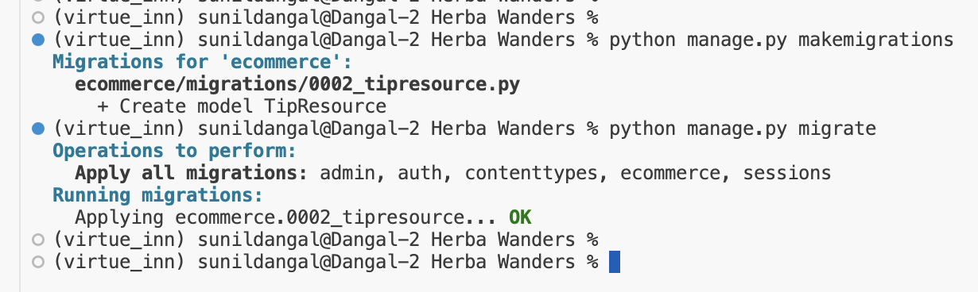

Now, to make it appear in the Django panel, remember we still need to register the models in admin.py file. So, let’s do that.

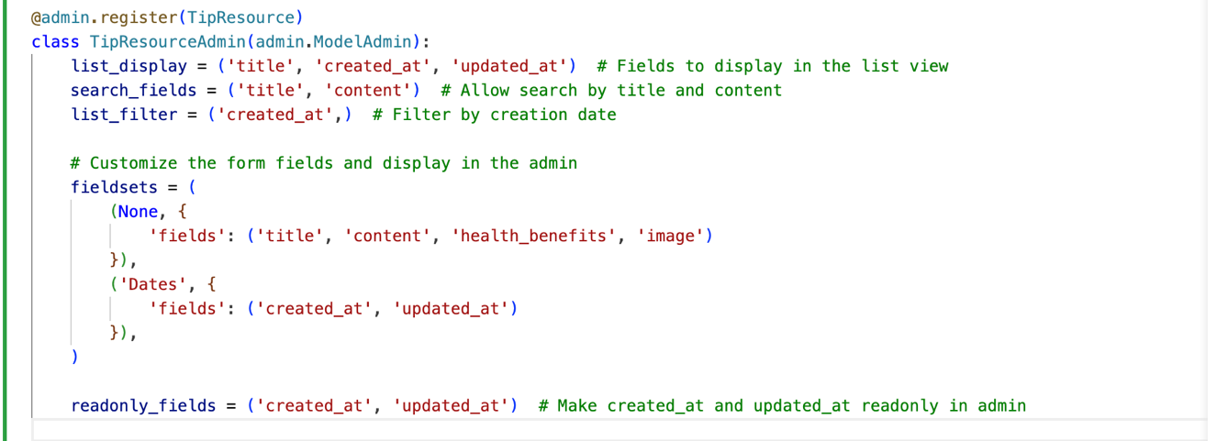

Now, you can see, we have created django panel to add Tips & Resources directly from admin.

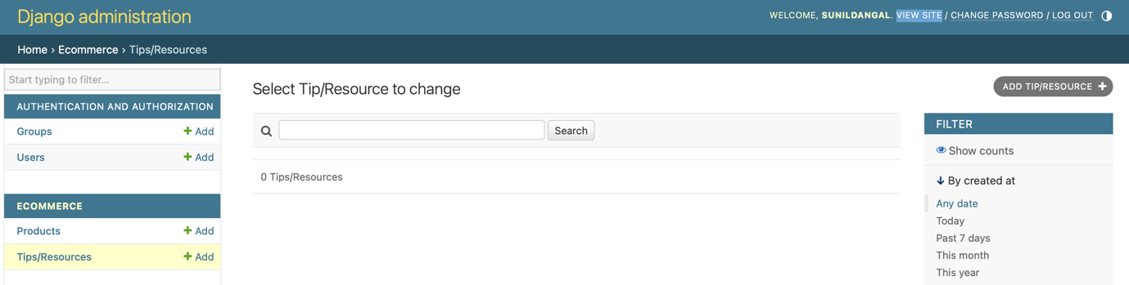

Now, to have Tips & resources appear in Tips & Resources page, we need to update tipsandresources.html page.

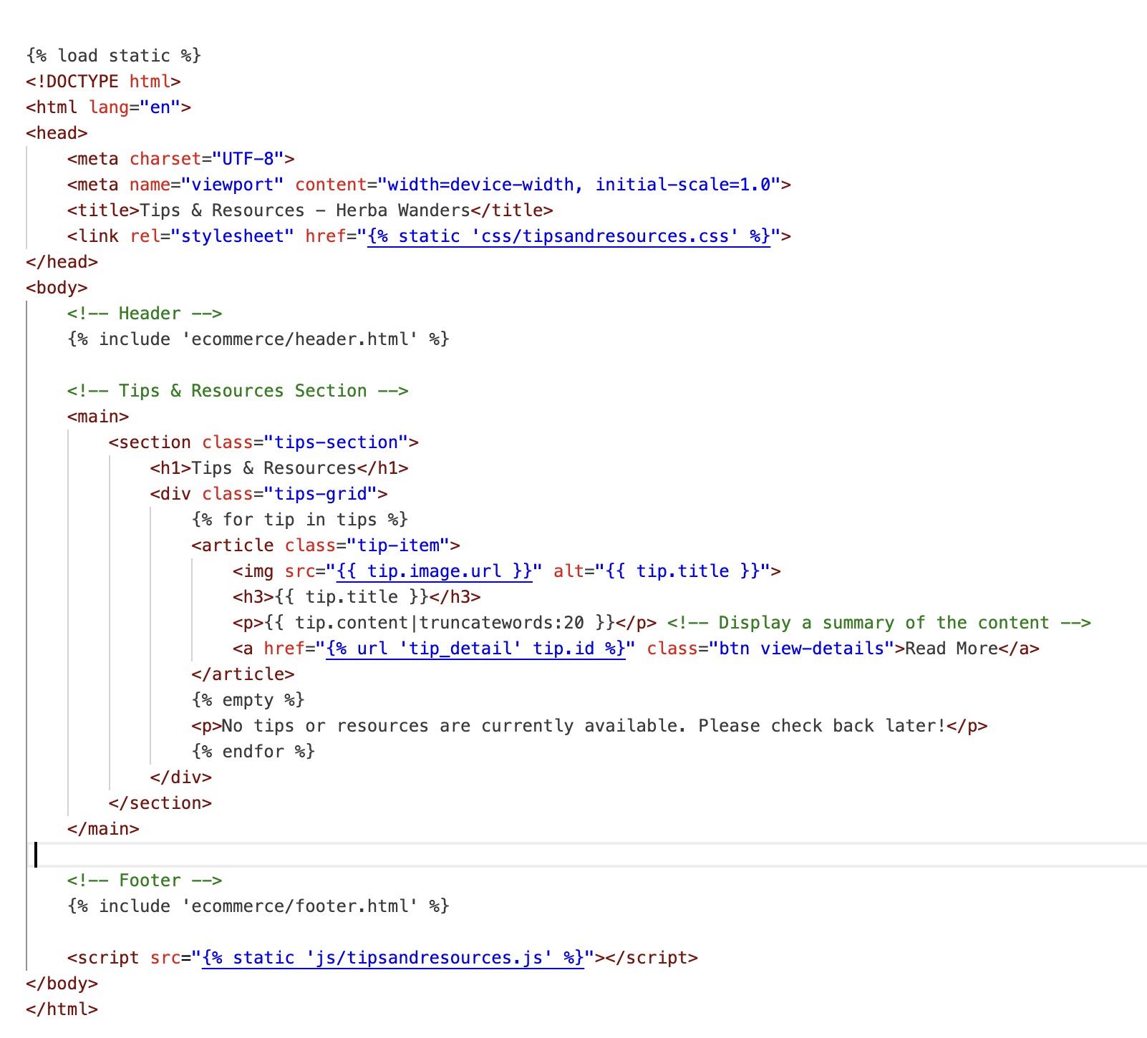

You can also update CSS based on your preference of styling.

Now, we are going to update views.py file to have tipsandresources function.

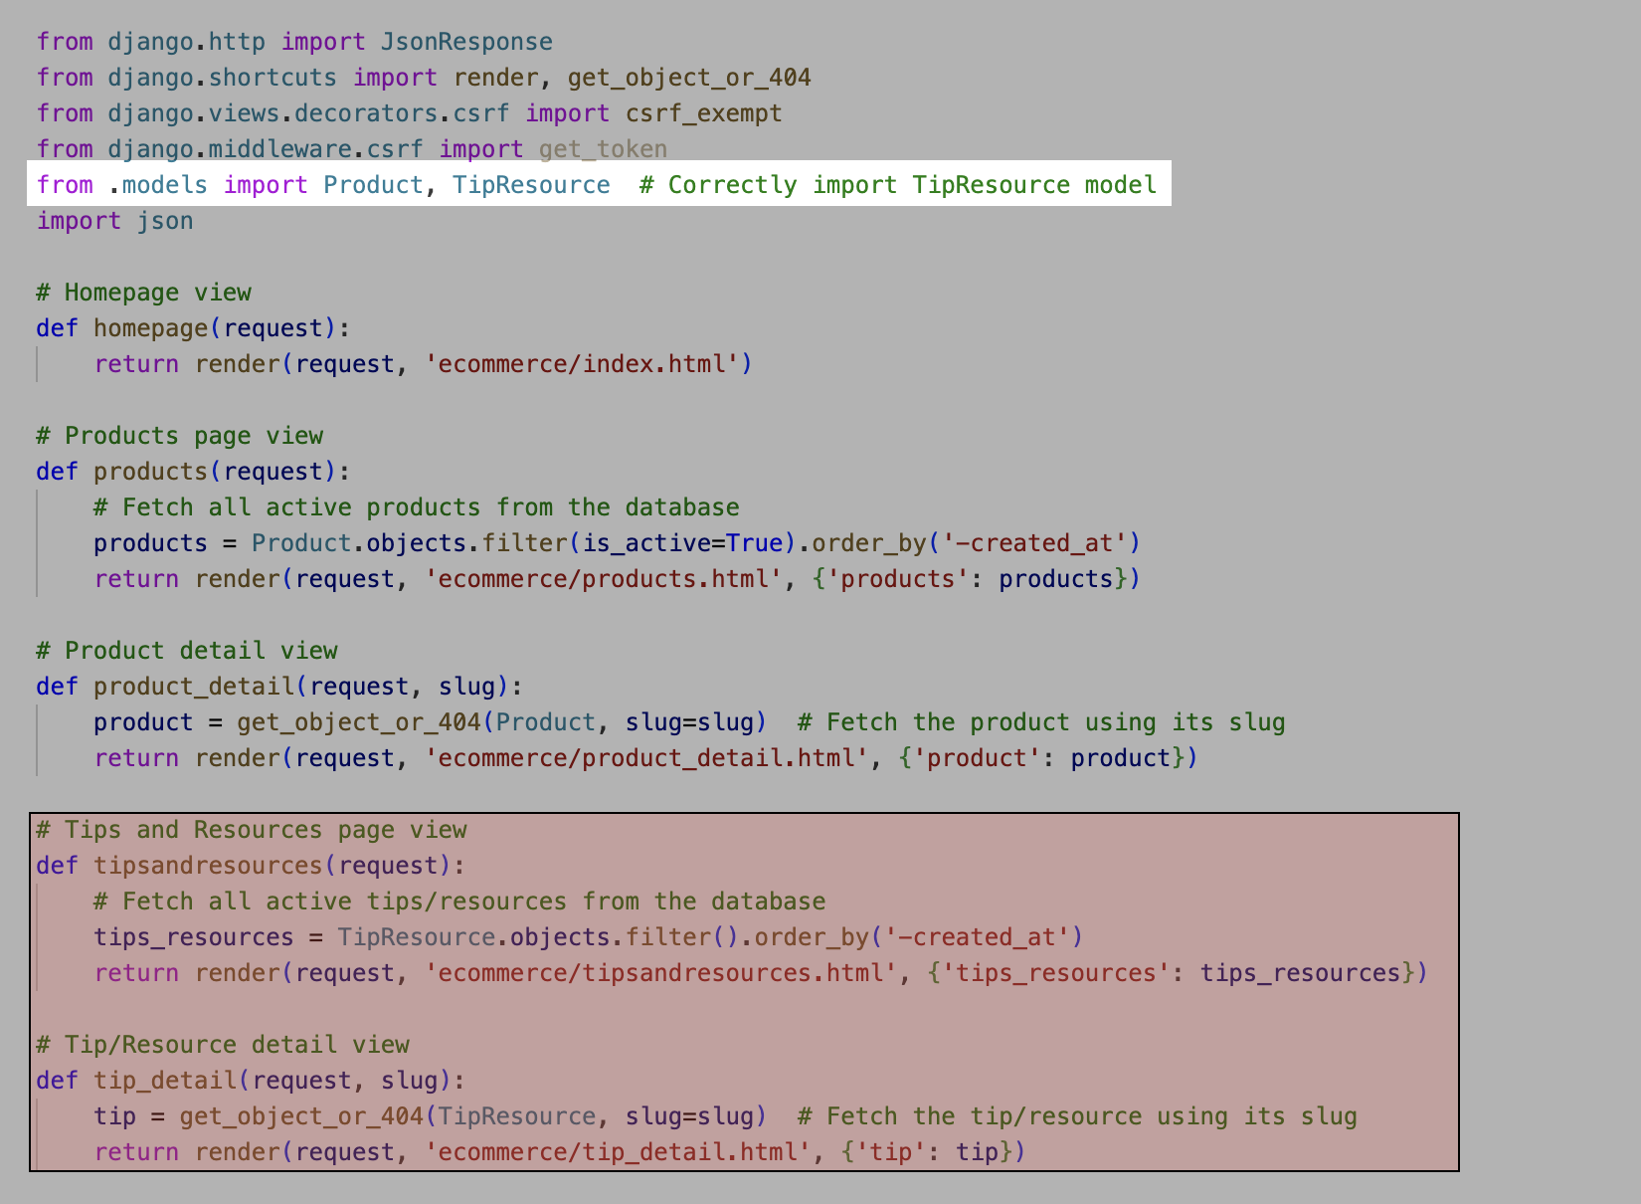

Now, we have updated new route or url path in urls.py.

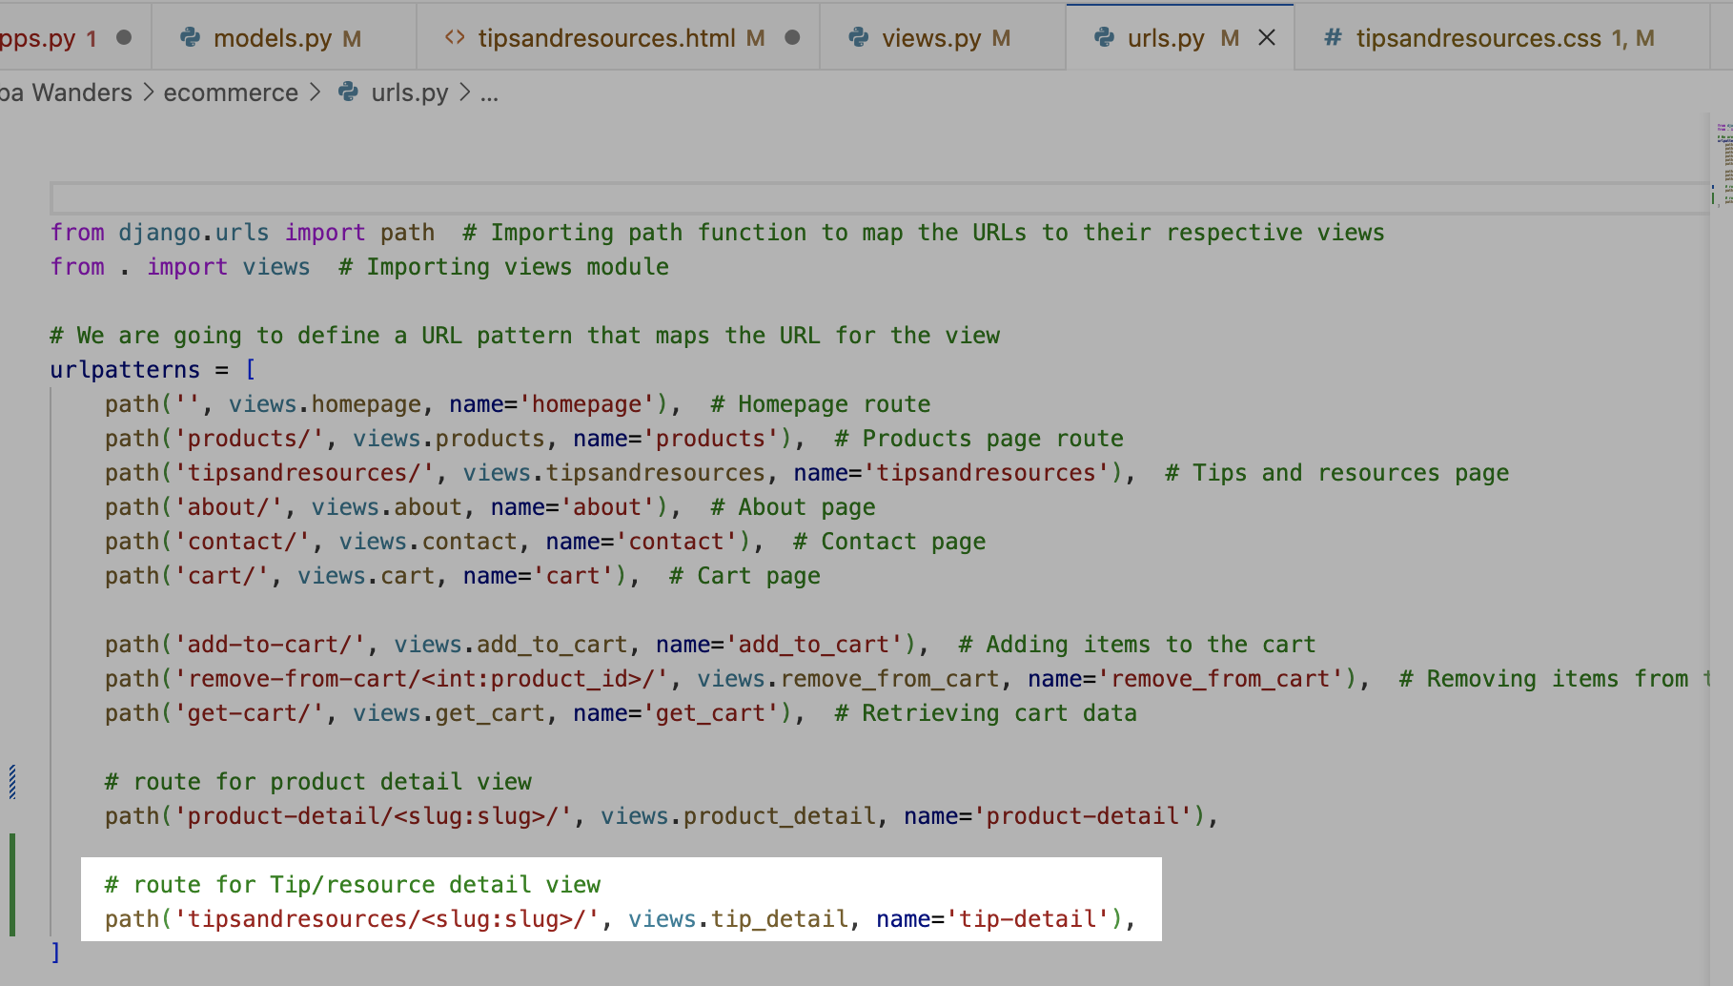

Now, let’s check the website, and we have full functional Admin view to add Tips and Resource blogs.

Now, Let’s add models for Meet our team in About page. We are going to make it easy to add team details from Django admin. Now we are going to do pretty much same process as we did before. Let’s write code inside models.py

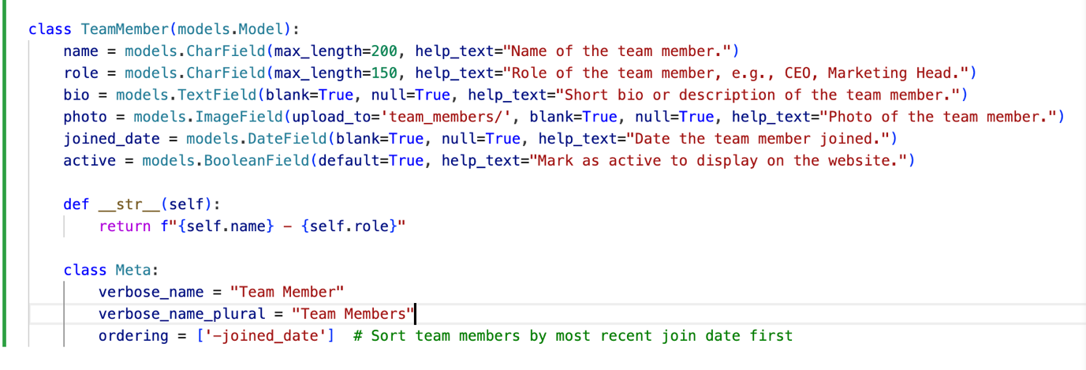

Next things, we need to do is run this:

1. python manage.py makemigrations
2. python manage.py migrate

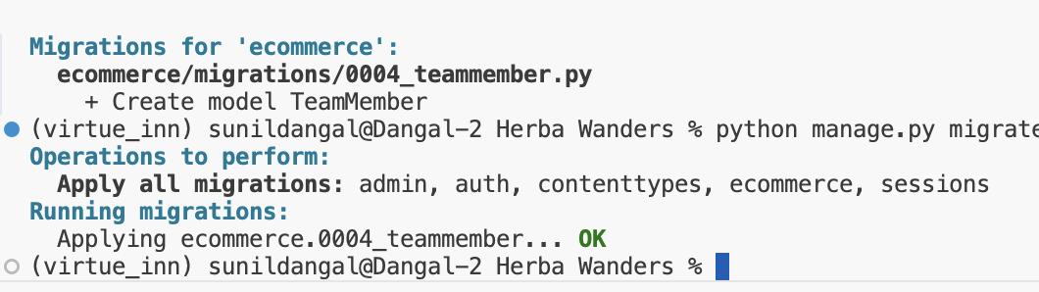

Now, in admin.py file, lets register our models.

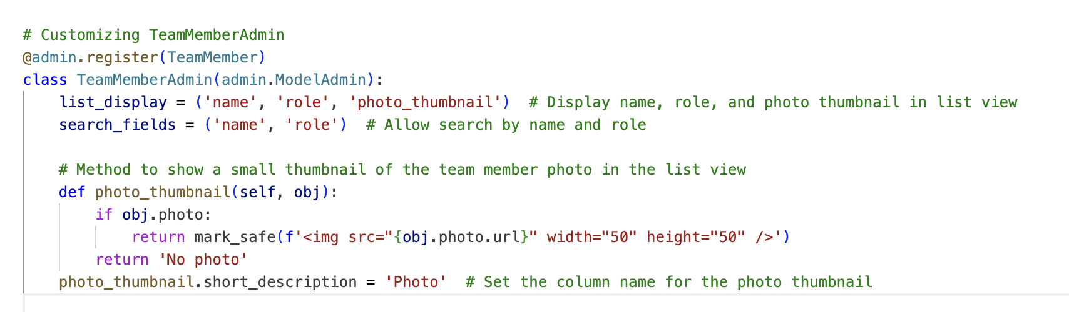

Now, just like how we added other models, we can see models to add team member in Django admin.

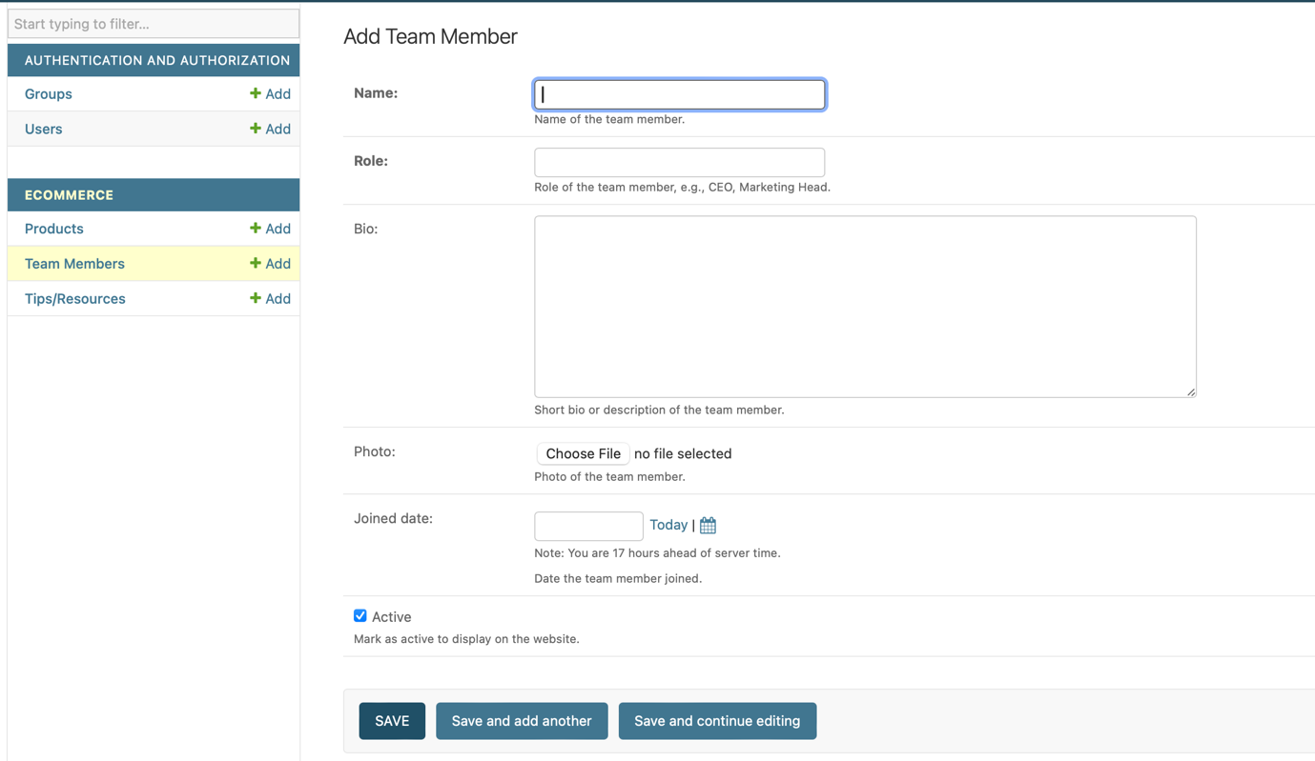

Now, to have the team member update in our webpage, we need to update the html codes in About page.

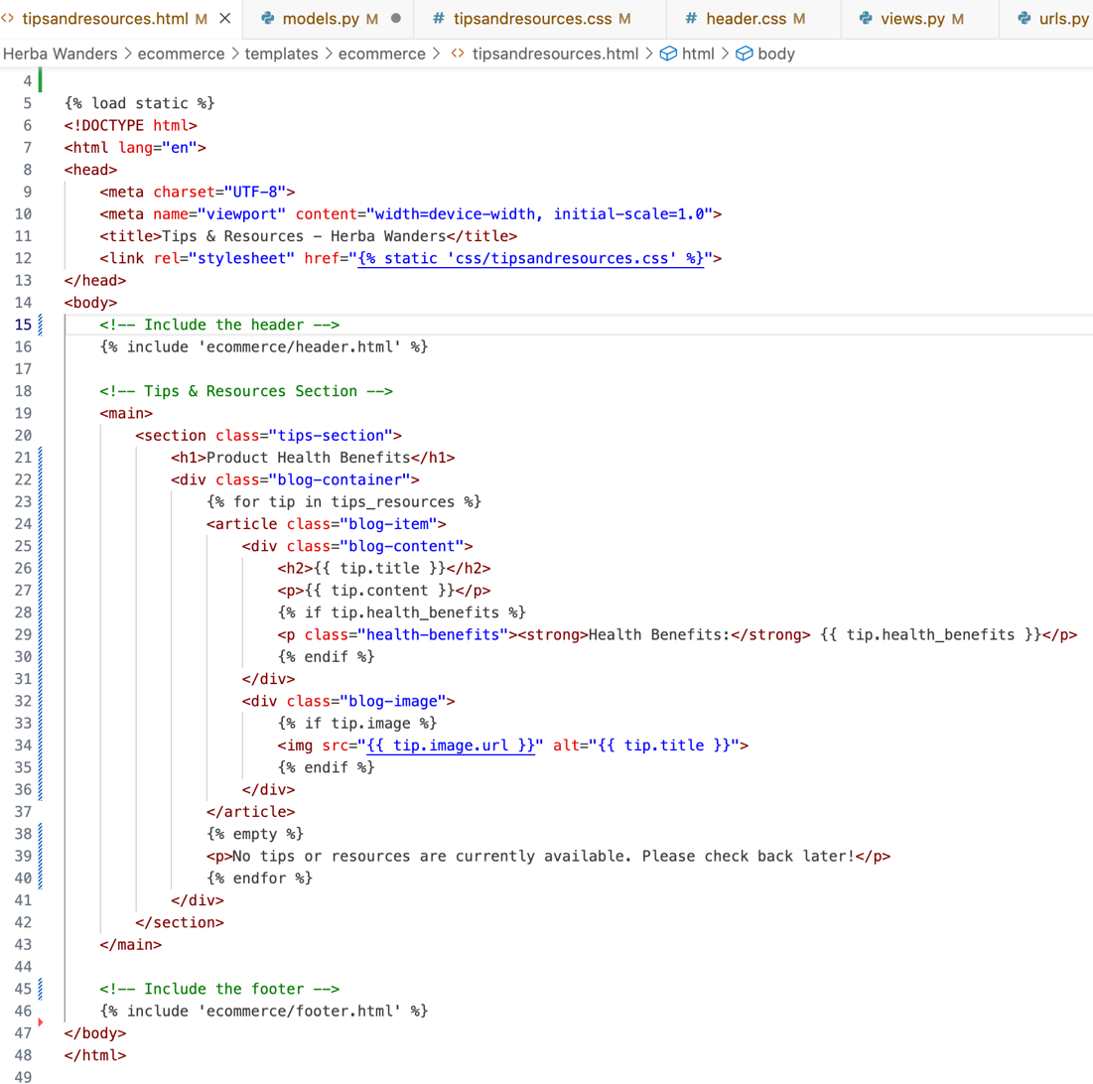

After that, we need to update views.py to load the Meet our teams’ contents from Django.

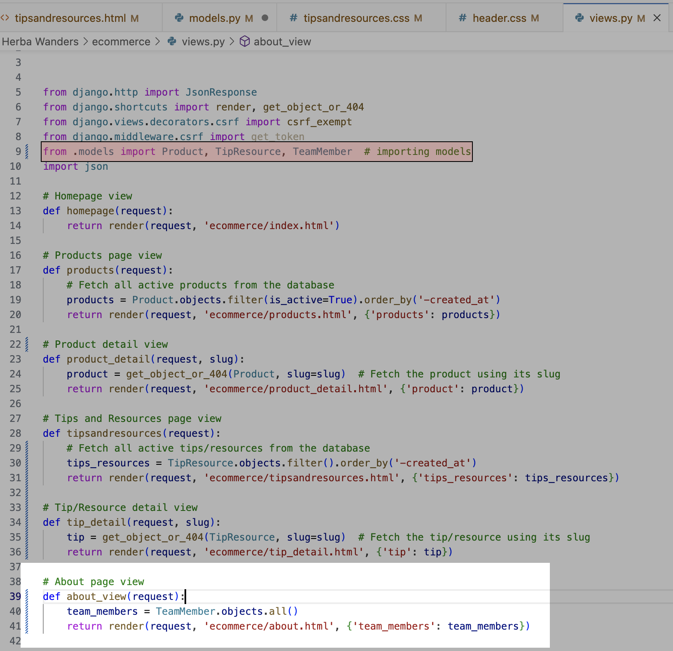

Let’s update urls.py too and let see. After that we can run python manage.py collectstatic and run server and we can see how we can update team members details directly from Django admin and show it on the website. Just like above process, I have also added models for adding offers from Django. Like, let’s say it Christmas time or holiday time or black Friday time, we can add offers directly from Django.

Now that we have create all the models that are required for the page. W are going to focus on the frontend part later and now for the backend, I am going to focus more towards making the cart functionality work. For example: When we add the item, then it should go to the cart and after that, it should show the total price in top of the cart when the products are added and after that, there should be featured to clear the cart, increase/decrease quantity of item and then process the payment later.

Now, after that, I have just fixed .CSS files for all to align, position and make the frontend look good. Now in the next stage, I am planning to add react technology to make even more amazing later and have more dynamic components.

## Frontend:

### React

Let’s add **react**. Now before we install react app, we need Node.js for React and npm (Node Package Manager) to handle React dependencies. So, in my terminal, I have run these commands and I can see I already have node and its package manager:

node -v

npm -v

And I got result of this:

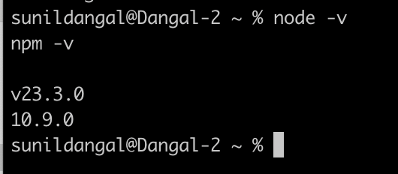

Now, I can see that I have the node and package manager version number. Now, let’s create a react app in the Django directory where there is manage.py file. So, we do:

npx create-react-app frontend --template typescript

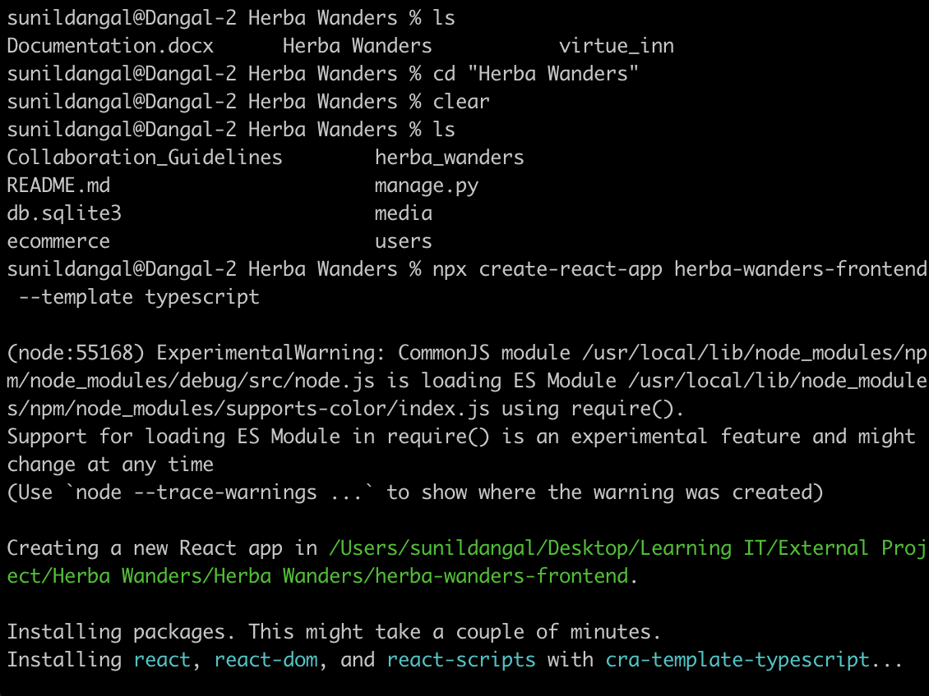

And we can see the react app is installed. Now, if you encounter the react version issues that the typescript support, then you need to downgrade the react version like I did and then only the smooth react installation happens. For example, when I installed react like in above way, I got lots of npm errors so, I downgraded react version to v18 by typing this:

npm install react@18 react-dom@18

and we need to check version to make sure by typing:

npm list react

npm list react-dom

And we can see this after:

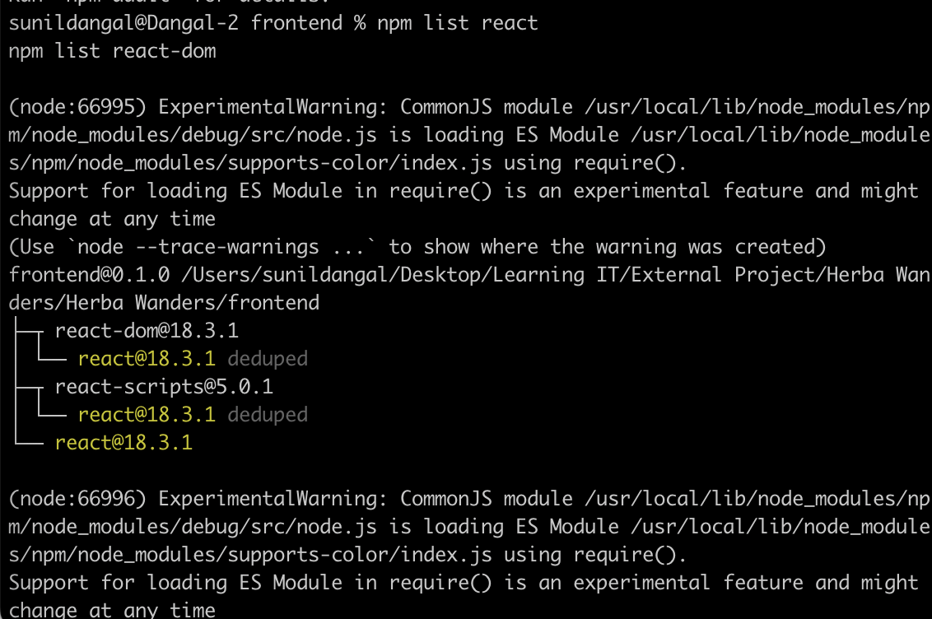

After, I run the server by typing:

npm start

I got the issue with two files, App.tsx and reportWebVitals.ts, and I fixed it by writing the file type inside index.tsx file and by installing webVitals package by:

npm install web-vitals

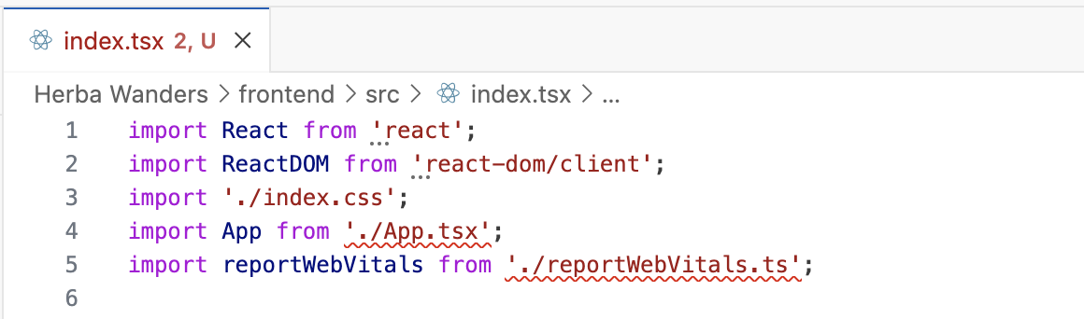

Now, when I ran the server then I can see the react application which means the server is now working. I can see a default react page.

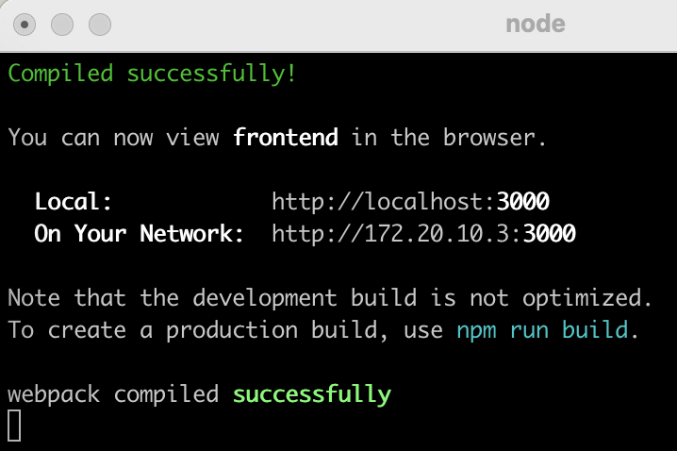

### Tailwind CSS

Now, let’s install Tailwind CSS for styling. In the frontend directory, we need to install tailwind CSS. So, we do:

npm install -D tailwindcss postcss autoprefixer

And to confim we have installed, we can check package.json file:

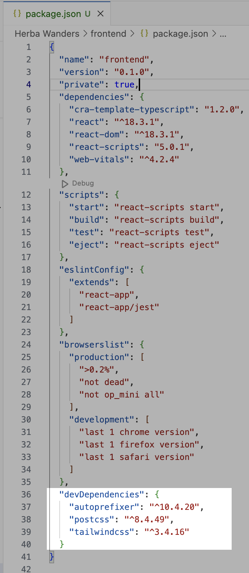

We can see the tailwind CSS version 3.4.16 in package.json file, Now we need to install the TailWind Configuration files. So, we do:

npx tailwindcss init

After installation, we can see tailwind.config.js file inside frontend folder. Inside that file we can see this:

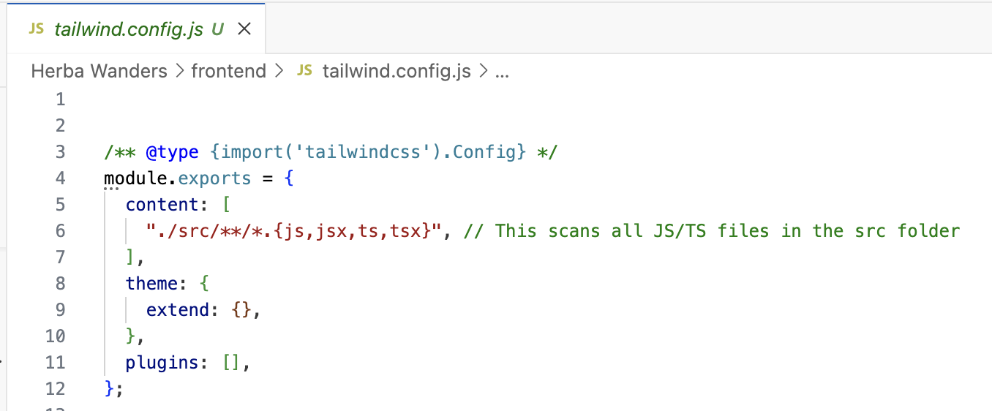

Now, after this, we need to setup, Tailwind in our CSS. So inside frontend directory, there is index.css file and inside there we write this for importing:

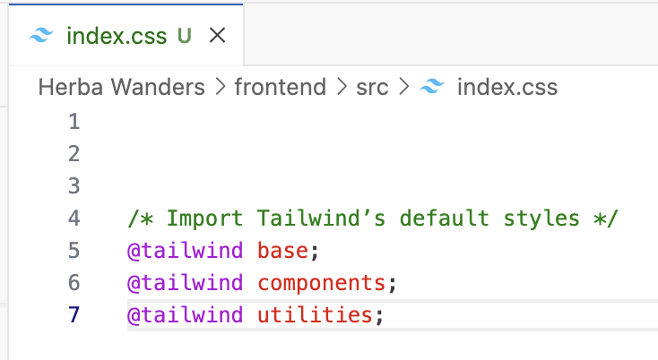

Again, we need to configure Post CSS, so, inside frontend directory, we create file named as postcss.config.js

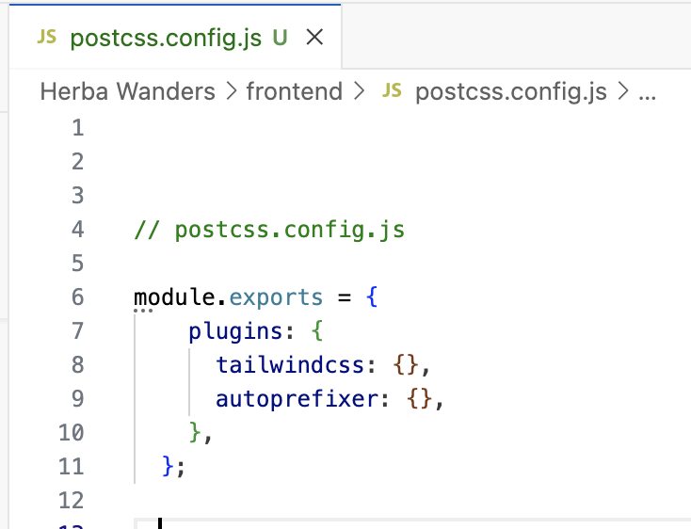

Now,

* + We need to make sure that src/index.css file has the correct Tailwind imports which we already did it above.
  + We need to make sure that import './index.css'; is imported inside src/index.tsx
  + We need to ensure postcss.config.js is there and contains configurations which we already did it above.
  + Lastly, we need to make sure inside tailwind.config.js file there are "./src/**/*.{js,jsx,ts,tsx}", // This scans all JS/TS files in the src folder.

And, if we do npm start, we can see the page.



### Organising react project:

Now, we are going to organise the react project to make it clean and easy to work later for debugging issues as the project scale. For example: we are going to organise like this inside the src folder in frontend directory:

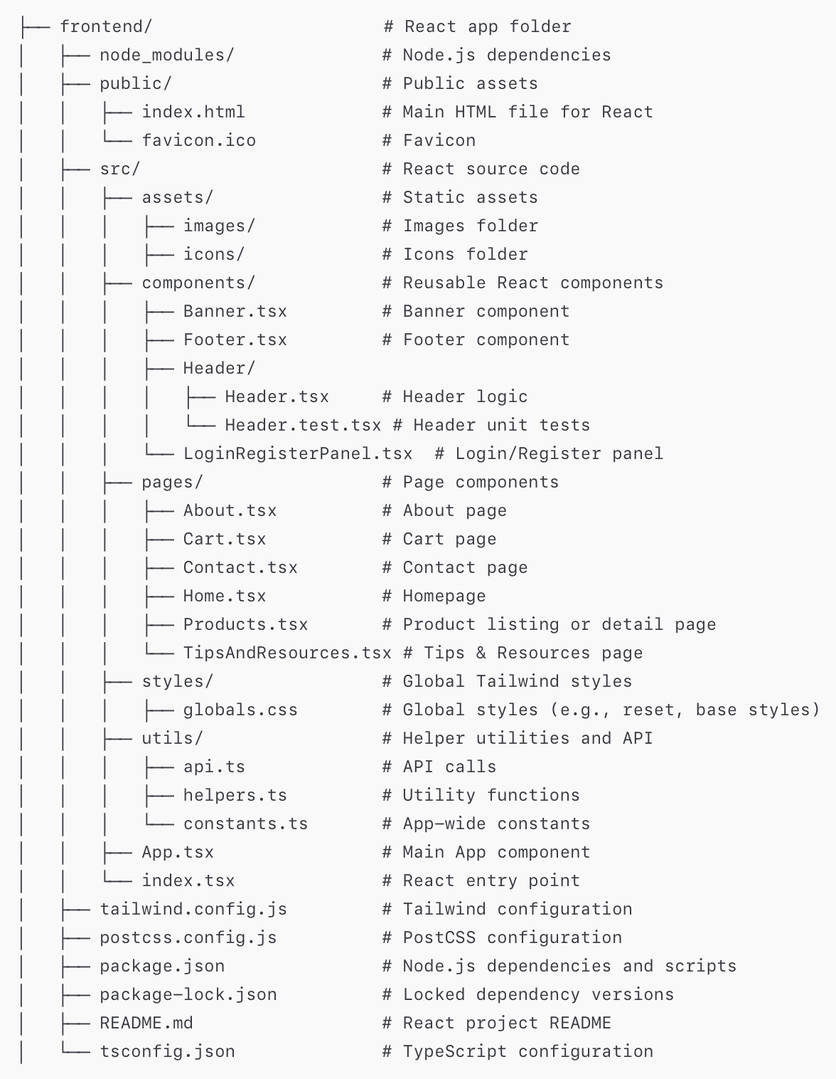

Now, What I have done is inside header.tsx I added the codes to make the frontend work. Also I have added codes inside products.tsx to show the 4 products that I want to sell. So everytime, we add codes inside the pages or components, we need to update inside App.tsx file. For example:

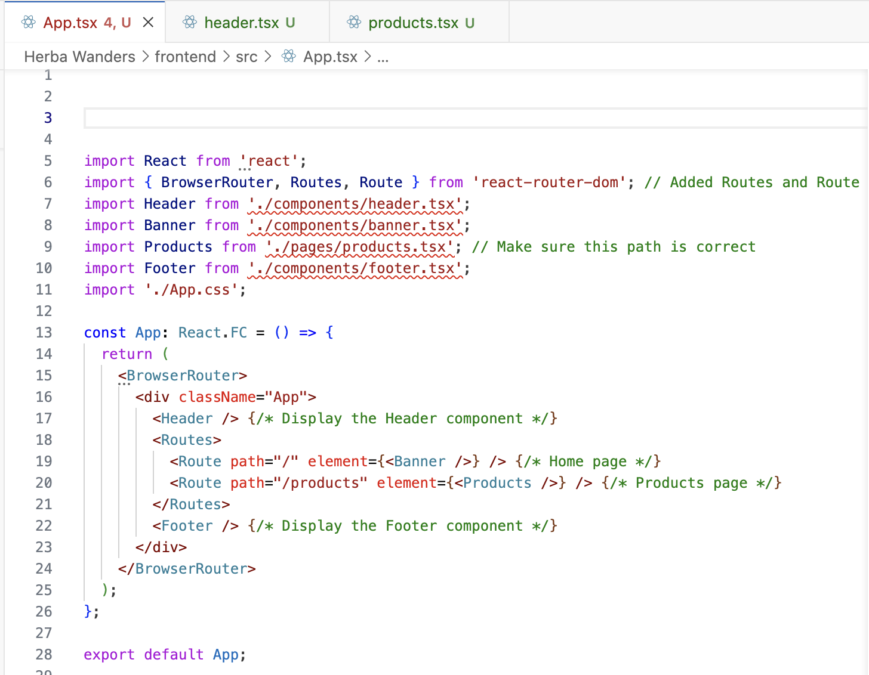

And we can see our home page and product page looks like this:

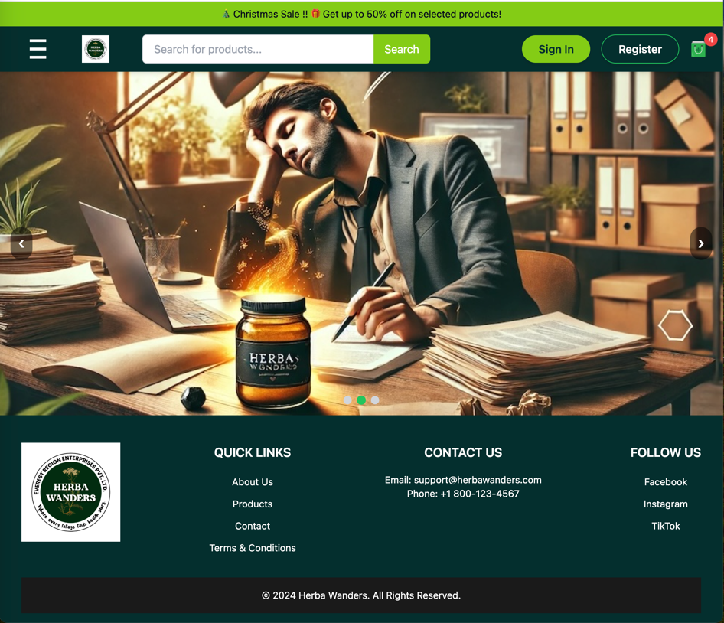

Figure 1Homepage

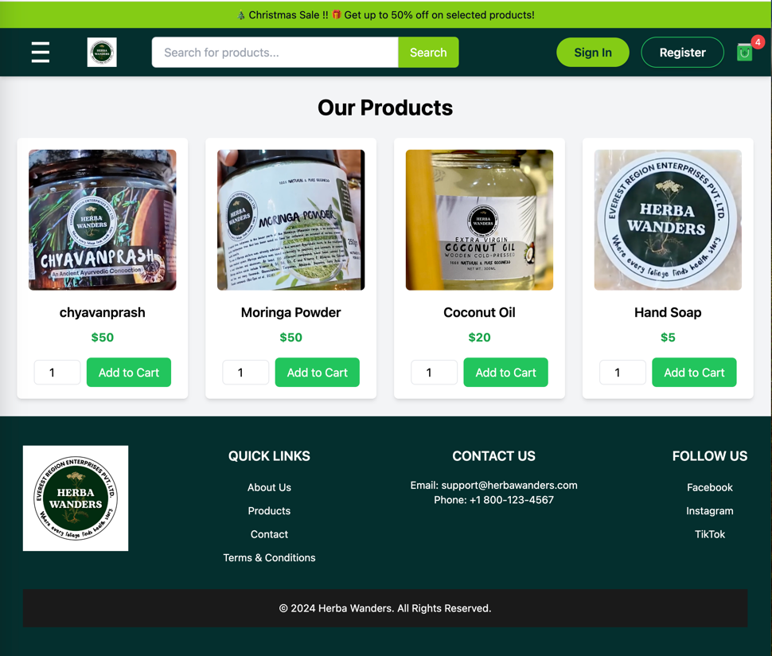

Figure 2Product Page

And just like that, I am going to add codes for all the pages, components to show the pages when the buttons are clicked. So basically, I have added all the pages. Now, all we need is a images like company logo, Cart logo, etc, that can be used professionally and trademarked. Icons for Home page, Produtcs, Tips & Resoures, About and Contact page also needs to be made.

I am currently using logo, icons from <https://www.flaticon.com>

And I want to give shoutout to redempticon for the maintenance logo.